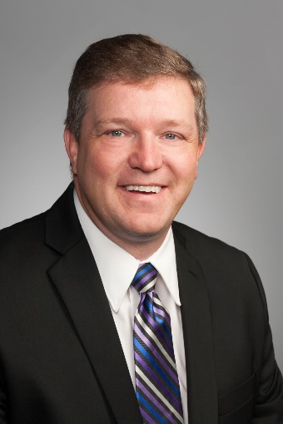
Project Manager:
Keith Olander

Dean of Agricultural Studies, Central Lakes College
Supervise 13 faculty in Agriculture, Food, & Natural Resources Education

Director of AgCentric, Minnesota State Center of Excellence in Agriculture
Coordinate Professional Development of Statewide Farm Business Management
Facilitate Database Construction, over 2100 farms
Eight Colleges within Minnesota State, 66 faculty

Director of Central Lakes College Ag & Energy Center, Central Lakes College
Facilitate over 40 public & private research partnerships
1800 acre research & demonstration in the following areas:

- Alternative Energy
- Cover Crops
- Soil Water Quality
- Irrigation Technology Management
- Local Foods Systems Catalyst
- Agronomic Crop Production

Owner & Operator, crop farm
350 acres of row crops – 30 year practitioner, rural Staples, MN
Demonstrating balance in environmental impact with financial sustainability
**As a practitioner, a large amount of credibility is extended when presenting to local farmers as they give credence to listening to “another farmer”.

Organization Description:
The Central Lakes College Ag and Energy Center is a catalyst for agriculture research and demonstration in the coarse, sandy plains of Minnesota. The mission of the Central Lakes College Ag and Energy Center is to build futures; as it delivers valuable products, services, and education, which contribute to the economic vitality of the region.
The Ag and Energy Center has built a network of farmers and agricultural partners in the region. The Center is guided by an advisory council that includes area farmers and will provide expertise on increasing the adoption of new crops by the farm community. Leading teams to meet grant and research objectives is integral to the mission of serving our region’s farmers. Aside from involving farmers in guiding farm demonstration, the Ag & Energy Center Director is the education liaison for local farm groups offering annual programming with an emphasis in water quality, monitoring, and “forever green” concepts like cover crops. The Ag & Energy Center has the capacity to handle full agronomic cycle of the crops in this project and the human resources to facilitate the administration of all aspects of the project. These relationships make the Ag & Energy Center uniquely positioned to effectively lead the effort to increase alternative crop adoption on the central sandplains to protect valuable groundwater.

