Project manager qualifications

Kevin McDonald, a 32-year veteran and leader at the Minnesota Pollution Control Agency, will oversee this project. Having begun his state service in 1987, Kevin has championed numerous innovations and initiatives to protect and improve our environment and enhance human health, and develop new pollution prevention programs. Noteworthy are Minnesota GreenCorps, the Minnesota Toxic Pollution Prevention Act of 1990, Minnesota Retiree Environmental Technical Assistance Program (RETAP), and the nationally recognized Get the Lead Out fishing tackle program. Kevin is MPCA’s representative on the Minnesota Shade Tree Advisory Committee. He currently supervises a team of seven MPCA professionals.
Kevin
McDonald

Organization descriptions
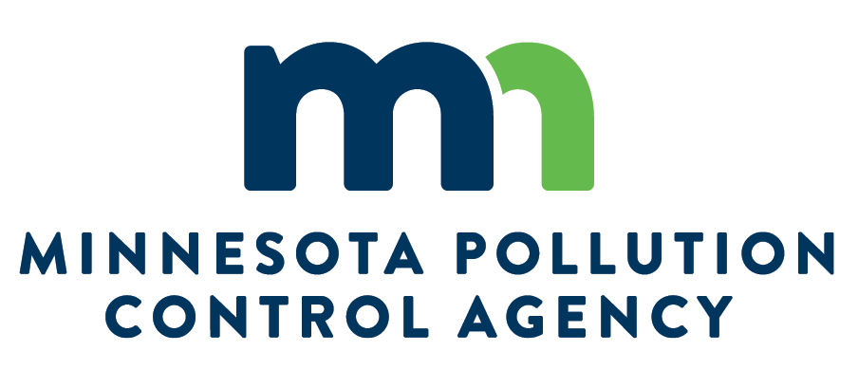
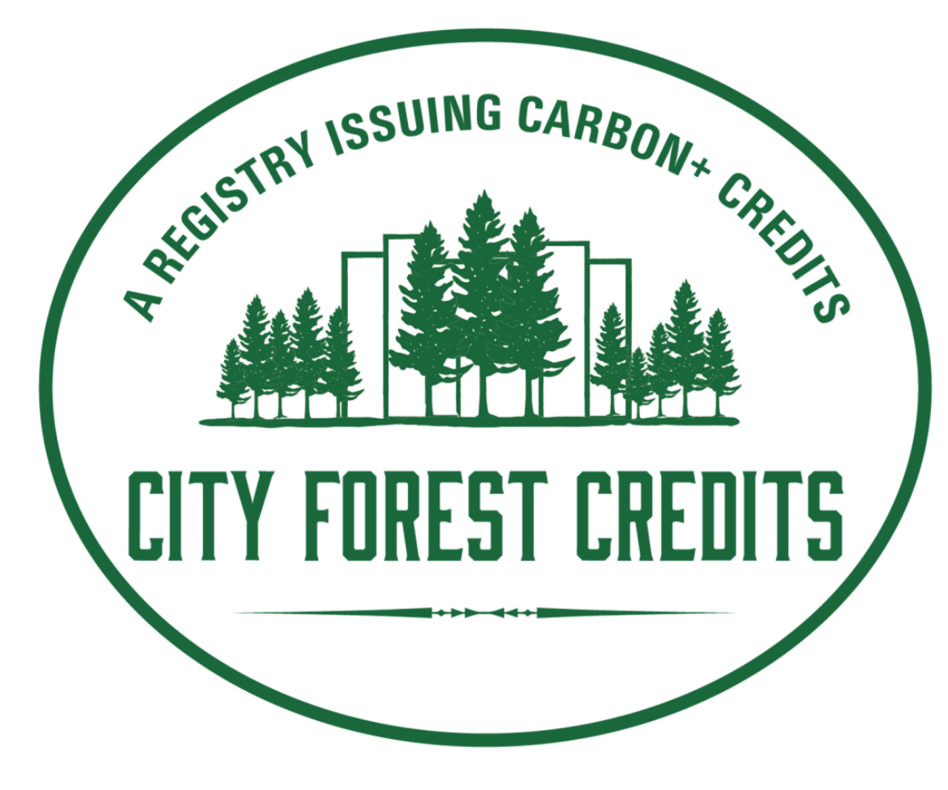
Minnesota Pollution Control Agency monitors environmental quality, offers technical and financial assistance and enforces environmental regulations. The MPCA finds and cleans up spills or leaks that can affect our health and environment. Staff develop statewide policy, and support environmental education. The MPCA works with many partners — citizens, communities, businesses, all levels of government, environmental groups and educators — to prevent pollution and conserve resources.

Working to protect and improve our environment and enhance human health.

City Forest Credits is a non-profit 501(c)(3) organization based in Seattle. Its mission is to bring the wide range of environmental benefits of trees to our cities and towns in America. It seeks to make American cities greener and healthier by enabling urban tree-planting and preservation projects to earn carbon credits to generate much-needed funding for our declining urban forests.
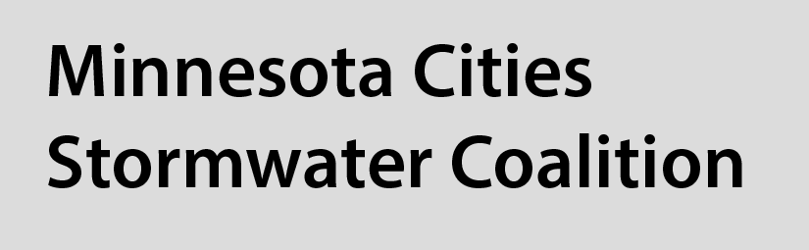
Minnesota Cities Stormwater Coalition The League of Minnesota Cities sponsors the Minnesota Cities Stormwater Coalition, an active network of over 120 cities that provides help to local governments in implementing various federal and state stormwater requirements.
The Minnesota Retiree Environmental Technical Assistance Program (RETAP) employs skilled, retired professionals to provide facility assessments and community sustainability assistance to small businesses, institutions, and communities in Minnesota. Funding and oversight is provided by MPCA.
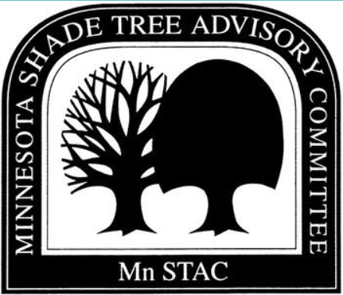
Minnesota Shade Tree Advisory Committee Since 1974, MNSTAC has been advising Minnesota's Governor, Legislature, other legislative and administrative branches of the state, the University of Minnesota, and the counties, communities, and people of the state of Minnesota on the best ways to preserve, protect, expand and improve Minnesota's urban and community forests.

