PROJECT TITLE: Clean Hydrogen Fuel from Sunlight, Wind, and Water

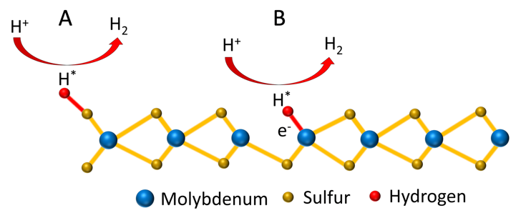
I. PROJECT STATEMENT
With renewable energy sources such as wind and solar becoming cheap and abundant, energy storage is the next frontier in the renewable energy ecosystem. Wind and solar energy are intermittent and require improved energy storage technologies for increasing adaptation. While battery technology has made great progress, grid-scale energy storage with batteries is still far from the horizon. Hydrogen is an attractive alternative for renewable energy storage. It has an energy density 200 times larger than current lithium ion batteries, can be compressed at low cost for storage, can be efficiently converted to electricity with fuel cells, and can be utilized as a clean, carbon-free transportation fuel. Here, we are proposing research to develop new, efficient and inexpensive catalysts for hydrogen production via water splitting using electricity from renewable sources.
Figure 1: Schematic of hydrogen evolution from atomically thin molybdenum disulfide. (A) edge reaction, (B) reaction at defect.
Steam reforming is the predominant way of producing hydrogen, however, it does not lend itself well to integration with renewable energy technologies. Electrical water splitting (electrolysis) can be established at a much smaller scale and is much easier to integrate with wind turbines, wind farms, or solar installations for on-site hydrogen production. However, the cost of this technology is still high, in part, because platinum is the catalyst of choice. Recent research has revealed molybdenum disulfide (MoS₂), which is used in motor oil for its lubricating properties, as a promising low-cost alternative to platinum. The challenge in enhancing the catalytic efficiency of MoS₂ is to make it atomically thin. We will achieve this goal by using a plasma technology developed in Professor Kortshagen’s laboratory to deposit atomically thin MoS₂ from an ionized gas.
Water is split only at the edges of an atomic layer flake of MoS₂, Fig. 1(A). Hence, to achieve the maximum amount of edge area (for a given surface area) to enhance the catalytic efficiency of MoS₂, the MoS₂ flakes should only be a few nanometers, meaning a few atoms, in diameter. Professor Kortshagen’s plasma technology is naturally capable of this and has been shown to produce MoS₂ flakes measuring just a few nanometers. This is a big advantage compared to the predominant technique of producing atomically thin MoS₂, called exfoliation, which starts from an MoS₂ powder and produces flakes of many 100s of nanometers to some micrometers in diameter.
Another way of enhancing the catalytic efficiency of MoS₂ is to deliberately introduce imperfections. The top and bottom surfaces of perfect MoS₂ (basal planes), such as those produced by exfoliation, are inert and do not participate in water splitting. Professor Kortshagen’s plasma technology is believed to be capable of “activating” the MoS₂ surface by deliberately introducing defects to create additional reactive sites, Fig. 1(B). We will study the combination of producing nanometer-scale MoS₂ flakes and introducing imperfections in the MoS₂ basal plane to enhance the efficiency of MoS₂ for hydrogen electrolysis.

II. PROJECT ACTIVITIES AND OUTCOMES

Activity 1 Title: Evaluate efficiency of nanometer-scale MoS₂ for hydrogen production
Description: Nanometer-scale MoS₂ will be produced via plasma deposition. Initial work will focus on small scale samples in an experimental reactor currently available in Kortshagen’s laboratory. Nanometer scale MoS₂ will be evaluated for hydrogen evolution efficiency in a electrochemical cell and its efficiency will be compared to larger-scale MoS₂ prepared by exfoliation.
ENRTF BUDGET: $79,199

Outcome | Completion Date
1. Prepare nano-scale MoS₂, characterize materials properties. | Dec. 31, 2020
2. Compare efficiency for hydrogen production of nano-scale MoS₂ compared to larger-scale exfoliated MoS₂. | June 30, 2021

Activity 2 Title: Study efficiency improvement of nanometer-scale MoS₂ through defect production
Description: Nanometer-scale MoS₂ will be exposed to plasma conditions that create defects such as missing sulfur atoms (sulfur vacancies) in the basal plane. Defect-treated MoS₂ will be evaluated for hydrogen evolution efficiency in a electrochemical cell and its efficiency will be compared to larger-scale MoS₂ prepared by exfoliation.

ENRTF BUDGET: $80,664

Outcome | Completion Date
1. Plasma-activation of nano-scale MoS_{2,} characterize materials properties. | Dec. 31, 2021
2. Compare efficiency for hydrogen production of defect-enhanced nano-scale MoS₂ compared to larger-scale exfoliated MoS_{2.} | June 30,2022

Activity 3 Title: Scale-up of MoS₂ deposition process
Description: The experimental reactor currently available in Kortshagen’s laboratory allows for deposition of 1 cm x 1 cm samples. This is sufficient for initial materials evaluations. Based on results of the first two activities, we will scale up the plasma process by modifying another reactor to attempt larger scale (15 cm x 15 cm) deposition.

ENRTF BUDGET: $80,137

Outcome | Completion Date
1. Scale-up of MoS₂ deposition process. Explore plasma conditions suitable for scale-up. | Dec. 31, 2022
2. Compare materials properties with those obtained in small scale deposition, determine important parameters for further scale-up of technology. | June 30,2023

III. PROJECT PARTNERS AND COLLABORATORS:
The project director, Professor Kortshagen, brings unique expertise in plasma materials synthesis. He is an inventor of a plasma technology that has been patented by the University of Minnesota and licensed to three companies. The project can leverage the research which is performed by the “Sustainable Nanocrystal Materials” group of the National Science Foundation-funded Materials Research Science and Engineering Center, a $17.8M federal grant from the National Science Foundation.

IV. LONG-TERM IMPLEMENTATION AND FUNDING:
This project will contribute to the improvement of a renewable energy storage technology, and subsequently will ameliorate the intermittency of renewable energy sources such as wind and solar. If successful, the outcomes of this work will contribute to the scientific knowledge base, but also hold prospect for commercialization. Based on the team’s unique expertise and prior success with technology commercialization, we hope to advance this technology into an asset for the State of Minnesota.

