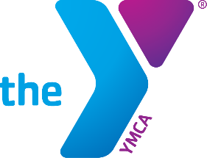

YMCA Project Manager Qualifications

The Project Manager for this program is Kurt Simer, Camp Director. Kurt directly hires and oversees all staff for this program. Kurt has worked with YMCA Camps for more than 8 years. He implemented the Boys Outdoor Leadership Development (BOLD) and Girls Outdoor Leadership Development (GOLD) programs at the YMCA and has been the driver for bringing our underserved communities into nature and providing life-changing experiences.
Kurt is a graduate of Hamilton College with a degree in economics. Realizing that outdoor education was his passion, the YMCA hired him from a stint as an instructor for the National Outdoor Leadership School to Direct Camp Widjiwagen, and then lead our BOLD/GOLD program

YMCA of the Greater Twin Cities Organizational Description

The YMCA of the Greater Twin Cities (YMCA) is a 501(c)(3) nonprofit organization which has served Minnesota for over 160 years. Our vision is to serve relentlessly until all can thrive in each stage of life. We carefully chose the word “relentlessly,” and it is central to our work: We are here for good. , the YMCA provides life-strengthening services across 12 counties of the Greater Twin Cities metro region; Rochester, Minnesota; and Hudson, Wisconsin. Our 28 YMCA branches and program sites, 8 overnight camps, 10 day-camps, and more than 90 child care locations serve 340,000 members annually. The YMCA is also steward of 3,719 acres of land, 680 acres of this owned by the YMCA through use agreements with property owners and municipalities. Our care of these resources remains priority as we strive to provide bring children, adults and families over decades access and understanding of the importance of our pristine wilderness.

The mission of the YMCA of the Greater Twin Cities is "to put Christian principles into practice through programs that build healthy spirit, mind and body for all." Our vision is to serve relentlessly with our community until all can thrive in each stage of life. The Y has a longstanding reputation for providing care that reflects compassion, integrity, and respect for all individuals and cultures regardless of race, color, creed, religion, national origin, sex, sexual orientation, disability, age, marital status or status with regard to public assistance.

