PROJECT TITLE: Mitigating Insecticide Toxicity for Safer Waters in Minnesota.

PROJECT STATEMENT: The health of all Minnesotans is threatened by the presence of toxic compounds found in everyday places such as soil, air, food, and even water. In a recent breakthrough, we have discovered a protein which can transform harmful toxins into harmless compounds, all within a matter of seconds. It is urgent that we take advantage of this discovery, and design products which will increase the safety and cleanliness of Minnesota’s water supply to protect both the environment and the health of its residents.
Extensive documentation has shown the presence of man-made toxic chemicals, such as hazardous pesticides, in the Minnesota water sheds. Among the most dangerous are organophosphorus compounds. These types of compounds have been linked to serious diseases and disorders such as: heart disease; neurologic developmental disorders in children including autism; and—especially in the state of Minnesota—a higher risk of leukemia among men. The use of organophosphorus compounds as the active ingredient in pesticides is startling. In 2012, more than 20 million pounds of this dangerous compound were used in the United States alone (EPA, Pesticides Industry Sales and Usage, 2008-2012). In Minnesota, they are used on all major crops (2013, 2016 Pesticide Usage Report, MDA). As a direct result, these compounds are contaminating Minnesota’s water, air and fresh produce (Pesticide Drift Monitoring in Minnesota Report, 2006-2009).
Organophosphorus pesticides are neurotoxic compounds, dangerous even in small amounts, which can accumulate in the body over time. These toxic compounds also have deleterious effects on aquatic life. Currently, the best solution to deal with these compounds is simply to limit exposure. However, due to the presence of the toxins in our immediate environment (air, water and food), this suggestion does little to prevent human mortality, intoxications, and diseases. Therefore, efficient solutions to remediate these toxins is one of the Holy Grails in environmental sciences. This research proposal is a direct outcome of an outstanding discovery in our laboratories. We recently found, for the first time, proteins that destroy organophosphorus insecticides in mere seconds. We have successfully infused these harmless biologicals into materials such as fabrics (view video here).
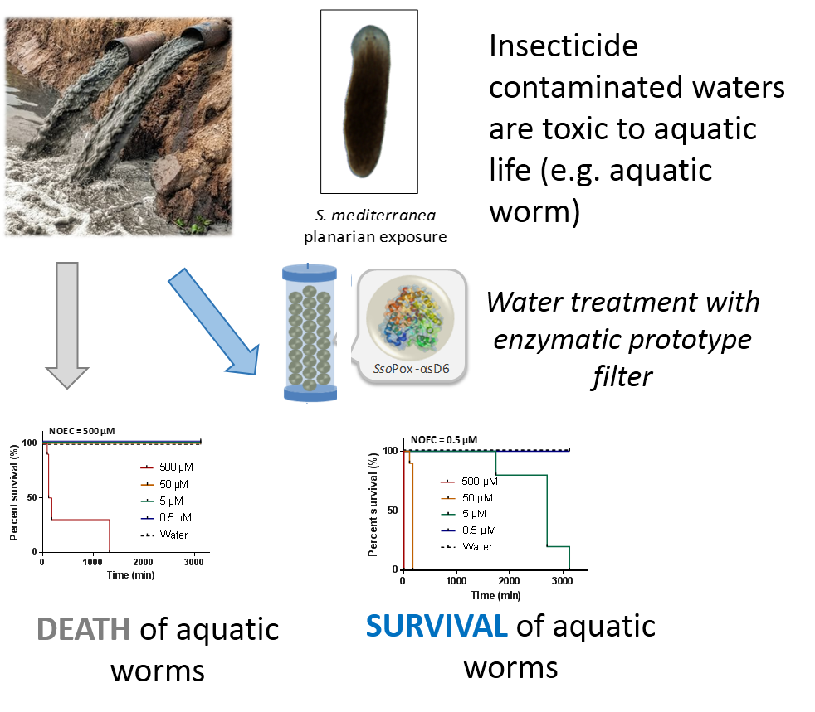
Figure 1: How a prototype enzymatic filter protects aquatic worms (planarians) from death from the toxic induced by the toxic insecticide (parathion).

Beyond these achievements, these proteins unveiled the existence of entirely new families of proteins produced by Minnesota mushrooms that could complement and add to our growing arsenal of detoxifiers. This is a unique opportunity to use the extraordinary diversity of our ecosystems to develop much needed tools to protect our children, and the aquatic environments. These achievements give our team an undisputable advantage and a distinct edge to develop prototype products based on these 100% biological molecules to clean water in real testing conditions. In order to achieve these goals, we propose to:
- Study and develop prototype products for cleaning water. We will develop and optimize water filtration prototypes with our active biologicals and measure their ability to clean water samples.
- Expand the decontamination ability of our biologicals toolbox by tapping into the hidden biological reservoir of the state of Minnesota.
This proposal will provide biological prototypes to solve serious contaminations issues (pollution of ground, surface, and drinking water) for which there are no satisfactory solutions. Moreover, these biologicals will serve as an ever-expanding and adaptable platform to neutralize other pollutants for which there are no effective solutions, such as the contamination of food products by man-made and natural toxins.

II. PROJECT ACTIVITIES AND OUTCOMES
Activity 1: Develop detoxification prototypes for cleaning water ENRTF BUDGET: 243,100$
We will take advantage of our recent discovery and success to affix our biologicals on surfaces in coatings, on fabrics, as well as in clay beads. We propose to develop and optimize prototypes of water filters containing active biologicals, as well as filtration resins, and evaluate their ability to clean lab-monitored water samples. We anticipate >90% reduction of the toxic chemicals after filtration, including the removal of degradation products.

Outcome | Completion Date
1. Production of water filters containing active biologicals. | December 1, 2020
2. Optimization of the water filters. | June 30, 2021
3. Measure the activity of filtration beads in ground and surface water samples. | November 30, 2021

Activity 2: Expand the decontamination ability of our biologicals toolbox ENRTF BUDGET: 126,900$

Outcome | Completion Date
1. Identify new biologicals for major emerging water pollutants | January 30, 2022
2. Production and optimization of water filters containing active biologicals | June 30, 2022
Besides organophosphorus pesticides, other compounds are present in Minnesota waters, such as Roundup (glyphosate) and other emerging contaminants. We have discovered new types of our biologicals that we will collect and harness from Minnesota resources (enormous variety of mushroom species) to degrade Roundup, as well as emerging pollutants such as pharmaceuticals and compounds from birth control pills.

III. PROJECT PARTNERS:
The assembled team is highly complementary, and has the unique set of skills required for this highly innovative project, as well as all the necessary resources to successfully perform the proposed research. Dr. Elias (PI, UMN, BTI) is an expert in organophosphorus degradation (> 20 research articles). Dr. Elias also has acquired experience in field testing using biologicals and has founded and lead biotechnology companies. Dr. Michael Freeman (co-PI, UMN, BTI)) is an expert in natural products. He has extensive experience in the isolation of new biologicals, especially from unusual sources such as fungi.
A. Partners receiving ENRTF funding
Name | Title | Affiliation | Role
Mikael Elias | Assistant Professor, PhD | University of Minnesota | Principal Investigator
Michael Freeman | Assistant Professor, PhD | University of Minnesota | Co-investigator

IV. LONG-TERM- IMPLEMENTATION AND FUNDING: After consulting with various stakeholders, including water treatment plants, local farmers, cooperatives, and packaging companies, we propose to evaluate the usefulness of our technologies in two different translational spaces. The water filtration matrices will be evaluated for their ability to be effective in conditions similar to existing water treatment steps to facilitate its translation. The biologicals-embedded filters will be evaluated for their ability to clean drinking water and eliminate all insecticides residues. Our existing IPs, and new IP generated from this study will be used to kick-start the creation of a startup company for the development, funding and translation of this research.

V. TIME LINE REQUIREMENTS: This project will take 24 months to carry out as described above. Thereafter, it is expected that the products of the project to be handed off to state agencies and the private sector.

