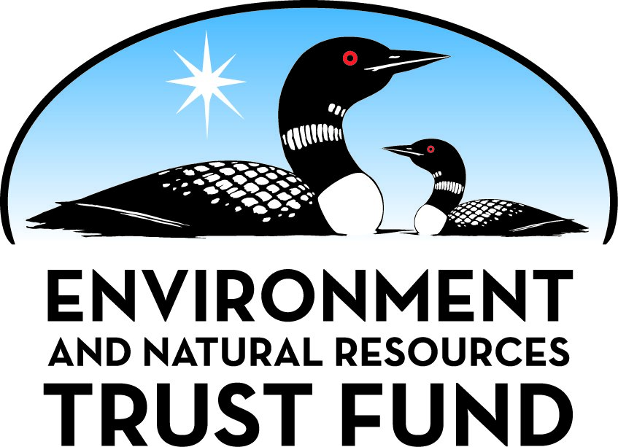

Environment and Natural Resources Trust Fund

M.L. 2025 Final Work Plan

General Information
ID Number: 2025-296
Staff Lead: Mike Campana
Date this document submitted to LCCMR: June 13, 2025
Project Title: Moving Minnesota towards a Lead-Free Sporting Future
Project Budget: $250,000

Project Manager Information
Name: Brian Hiller
Organization: Minnesota State Colleges and Universities - Bemidji State University
Office Telephone: (218) 755-2212
Email: bhiller@bemidjistate.edu
Web Address: https://www.bemidjistate.edu/

Project Reporting
Reporting Schedule: March 1 / September 1 of each year.
Project Completion: June 30, 2028
Final Report Due Date: August 14, 2028

Legal Information
Legal Citation: M.L. 2025, First Special Session, Chp. 1, Art. 2, Sec. 2, Subd. 05r
Appropriation Language: $250,000 the first year is from the trust fund to the Board of Trustees of the Minnesota State Colleges and Universities for Bemidji State University to conduct educational outreach directed at hunters and anglers to increase awareness of lead-free options for big-game hunting, small-game hunting, and fishing as a means of reducing wildlife exposure to lead.
Appropriation End Date: June 30, 2028

Narrative
Project Summary: We will use educational outreach to increase awareness of lead-free options for big game hunting, small game hunting, and fishing as a means of reducing wildlife exposure to lead.
Describe the opportunity or problem your proposal seeks to address. Include any relevant background information.
Lead has no biological benefits and has been removed from nearly all traditional human uses yet is still a primary component in ammunition and fishing tackle around the world. The widespread use of lead in hunting and fishing activities continues to be a problem in Minnesota as it routinely results in the unintentional poisoning of wildlife. These illnesses and deaths are preventable through a simple change in materials used in hunting ammunition and fishing tackle. Encouraging voluntary switch in hunting ammunition and fishing tackle choices through education can reduce the amount of new lead deposited in the environment and the unintended illnesses and wildlife death that results.
What is your proposed solution to the problem or opportunity discussed above? Introduce us to the work you are seeking funding to do. You will be asked to expand on this proposed solution in Activities & Milestones.
This project seeks to use an educational outreach approach to encourage hunters and anglers to voluntarily switch their hunting ammunition and fishing tackle to lead-free alternatives. Switching hunting ammunition and fishing tackle to lead-free versions to reduce wildlife illnesses and/or deaths due to unintentional exposure to lead.
What are the specific project outcomes as they relate to the public purpose of protection, conservation, preservation, and enhancement of the state’s natural resources?
The outcomes of this project include increased awareness of the lead-free alternatives available for use in big game, small game, and fishing tackle. This increased awareness of the alternatives to lead will, through voluntary means, decrease the use of lead for hunting and fishing throughout Minnesota thereby reducing lead in the environment and reduce lead exposure in a variety of wildlife.

Project Location
What is the best scale for describing where your work will take place?
Statewide
What is the best scale to describe the area impacted by your work?
Statewide
When will the work impact occur?
During the Project and In the Future

Activities and Milestones

Activity 1: Grassroots outreach and education on lead-free alternatives via direct contact with big game hunters, upland game hunters, and anglers.
Activity Budget: $170,000
Activity Description:
We propose to work with large-scale expos around the state such as Game Fair, the Governor’s Deer and Fishing Opener celebrations, and various outdoor sports shows held around the state. We propose having an increased presence during hunter sight-in season and utilize our growing network of professional partners to share volunteering workload help across all educational programing workshops, demonstrations, and other events. We propose to increase advocacy to non-convention/expo/gun-range-attending demographics. We will also develop and further connections with tribal communities and identify gaps or challenges regarding ammunition sourcing around reservations and rural areas less likely to locally stock odd calibers in non-lead. We could reach ~10-25% local-only hunters via brick-and-mortar store marketing campaigns, collaborating with hunting access groups, and landowners directly. We will also help hunters establish group-buy practices or increase local ammo distribution via petitioning their local sellers.
We will purchase ballistic performance learning tools, provide ammo testing opportunities, word-of-mouth, and media kits to help better inform people in their decision making. We will also conduct train-the-trainer workshops offer participants to sample various projectile offerings to inform their own purchasing decisions and better inform their cohort on what to expect when first making the adjustment to non-lead.
Activity Milestones:
Description | Approximate Completion Date
Make 2000 contacts via outreach efforts in the first year of work. | June 30, 2026
Make and addtional 3000 outreach contacts via demonstrations and education booths at range days/shows. | June 30, 2027
Make a further 4000 contacts via sight in days and governor's sporting opener events. | June 30, 2028

Activity 2: Using digital media to inform those considering switching to lead-free alternatives and provide users with updated retailer locations.
Activity Budget: $80,000
Activity Description:
We propose to use a variety of digital media platforms (Instagram, Facebook, YouTube, and a dedicated Website) to exemplify lead-free ammo and fishing tackle performance, value, and conservation mindset behind their use. These will likely be presented in that order based on common hunter responses to this advocacy effort in the past. We will not be proselytizing trophy animal carcasses, but rather highlighting noteworthy insights, helpful tools, product tests, in-stock notifications, shareable clips, and further public engagement via the various platforms.
We propose a dedicated website that will be used to inform yet will also provide robust search tools for products and ballistic charts. The website will also contain buying strategies for hunters, shooters, and anglers so they may get the best choice for their hunting or angling situation. The website will have mobile and desktop usability for “on-the-go” price and availability checks. These features will increase return visit metrics compared to similar organizations.
Real-time examination of print and digital product catalogs from major manufacturers (Federal Premium, CCI, Remington, Barnes, Norma, Nosler, etc.) to simplify hunters’ search for lead-free ammo and (Northland, Clam, Rapala, Berkeley, etc.) to simplify anglers’ search for lead-free fishing tackle.
Activity Milestones:
Description | Approximate Completion Date
Contract for development of a website and moble app for lead-free information. | January 31, 2026
Development of digital content and engagement (3 posts/week) via social media platforms | June 30, 2026
Continued content creation and engagement via social media (1 video/month); additional recording engagement metrics. | June 30, 2027
Continued content creation and engagement via social media (12 posts, 1 video/month) | June 30, 2028

Project Partners and Collaborators
Name | Organization | Role | Receiving Funds
Lead-Free Wildlife Minnesota | Minnesota Chapter of The Wildlife Society (MNTWS) | MNTWS/Lead-Free Wildlife Minnesota has been a pioneer in lead-free outreach in Minnesota since 2014 and they will collaborate on events and demonstrations. | No

Dissemination
Describe your plans for dissemination, presentation, documentation, or sharing of data, results, samples, physical collections, and other products and how they will follow ENRTF Acknowledgement Requirements and Guidelines.
The entire focus of this project is dissemination of information regarding non-lead ammunition and fishing tackle. We will be educating hunters and anglers at a variety of large-scale expos around the state such as Game Fair, the Governor’s Deer and Fishing Opener celebrations, and various outdoor sports shows held around the state. We propose having an increased presence during hunter sight-in season, as well as pheasant and fishing opener activities, and to utilize our growing network of professional partners to share volunteering workload help across all educational programing workshops, demonstrations, and other events. We propose to develop information tools that can be disseminated using a variety of methods including pamphlets/brochures and in-store displays, in-person shooting educational demonstrations, and digital media via social media outlets and a website portal. We will also develop and further connections with tribal communities and identify gaps or challenges regarding ammunition sourcing around reservations and rural areas less likely to locally stock odd calibers in non-lead. We will also collaborating with fishing and hunting access groups, as well as landowners and lake associations to provide information regarding non-lead options directly. The goal of this project is to inform hunters and anglers regarding their choices in ammunition and fishing tackle and encourage them to volutarily switch their purchasing choices to non-lead alternatives. This switch to non-lead hunting ammo and fishing tackle will reduce the unnecessary and preventable exposure of Minnesota's wildlife (especially raptors such as eagles and loons) to lead poisoning. Switching will also reduce the amount of lead ammo and fishing tackle that is distributed across the Minnesota landscape, resulting in a healthier environment for people and wildlife.
All physical materials purchased through this grant will be housed a Bemidji State University in perpetuity for use in futher educating hunters and anglers on the benefits of switching their sporting gear to non-lead options.
We will acknowledge the ENRTF in every presentation, information packet, and event where we participate.

Long-Term Implementation and Funding
Describe how the results will be implemented and how any ongoing effort will be funded. If not already addressed as part of the project, how will findings, results, and products developed be implemented after project completion? If additional work is needed, how will this work be funded?
Following the successful implementation of our outreach project we will continue this work by merging with a Montana- based, nationally recognized grassroots organization advocating the voluntary switch to lead-free sporting alternatives (Sporting Lead Free). Merging with Sporting Lead Free will allow the work to continue in Minnesota while defraying the cost to the parent organization.

Budget Summary
Category / Name | Subcategory or Type | Description | Purpose | Gen. Ineli gible | % Bene fits | # FTE | Class ified Staff? | $ Amount
Personnel
Project Manager |  | Supervision of contractor and working events to ensure completion of deliverables. |  |  | 22% | 0.36 |  | $25,000
 |  |  |  |  |  |  | Sub Total | $25,000
Contracts and Services
TBD | Service Contract | We propose building a dedicated website that will be used to inform yet will also provide robust search tools for products and ballistic charts. The website will also contain buying strategies for hunters, shooters, and anglers so they may get the best choice for their hunting or angling situation. |  |  |  | 0.75 |  | $72,000
Associate Coordinator- Lead Free Wildlife Minnesota | Service Contract | This position will assist with the implementation of an initiative to encourage the manufacture, sale and use of environmentally preferred lead-free ammunition and fishing tackle. The position will be responsible for staffing a large number of public education and outreach activities targeting hunter and angler groups, ammunition and tackle manufacturers. |  |  |  | 2.25 |  | $113,000
 |  |  |  |  |  |  | Sub Total | $185,000
Equipment, Tools, and Supplies
 | Tools and Supplies | Trade show supplies (backdrop, table cloth, etc), ballistic gel blocks for demonstrations, ear and eye protection, targets, target stands | Run shooting demonstrations and host events. |  |  |  |  | $15,000
 |  |  |  |  |  |  | Sub Total | $15,000
Capital Expenditures
 |  |  |  |  |  |  | Sub Total | -
Acquisitions and Stewardship
 |  |  |  |  |  |  | Sub Total | -
Travel In Minnesota
 | Conference Registration Miles/ Meals/ Lodging | 25 trips (milage, meals, lodging) | Registration at events. Travel to events; Such as, but not limited to, Game Fair, Deer and Turkey Classic, Duluth Sports Show, St. Paul Ice Show |  |  |  |  | $10,000
 |  |  |  |  |  |  | Sub Total | $10,000
Travel Outside Minnesota
 |  |  |  |  |  |  | Sub Total | -
Printing and Publication
 |  |  |  |  |  |  | Sub Total | -
Other Expenses
 |  | Booth fees | Fees set up an educational booth at trade shows. |  |  |  |  | $15,000
 |  |  |  |  |  |  | Sub Total | $15,000
 |  |  |  |  |  |  | Grand Total | $250,000

Classified Staff or Generally Ineligible Expenses
Category/Name | Subcategory or Type | Description | Justification Ineligible Expense or Classified Staff Request

Non ENRTF Funds
Category | Specific Source | Use | Status | $ Amount
State
 |  |  | State Sub Total | -
Non-State
 |  |  | Non State Sub Total | -
 |  |  | Funds Total | -

Total Project Cost: $250,000
This amount accurately reflects total project cost?
Yes

Attachments

Required Attachments

Visual Component
File:

Alternate Text for Visual Component
The graphic highlights grassroots outreach events such as tabling at trade shows, live raptor shows, and hosting shooting demonstrations. Other aspects of the graphic include possible lead exposure to scavenging animals, lead deposition via ingestion for birds, and our proposed social media creation and engagement goals....

Difference between Proposal and Work Plan

Describe changes from Proposal to Work Plan Stage
The changes between the original proposal and the the workplan stage includes the addition of a "Dissemination" section which details how we will spread the information from our project throughout Minnesota and how we plan to ensure that the materials purchased via this grant will be used to continue to the work and be available to benefit Minnesota's natural resources.
Additional changes in this version are a reshuffling of how and where the budget will be allocated among the different needs in order to complete the described deliverables.
The most recent changes are to the budget for attending/traveling to shows/events. I have moved some of the money originally allocated into the budget for the contract.
I changed the category in Travel/Conferences from other to Conference miles/meals/lodging.
I added registration for events to the category to match the heading/category type. This will be used to pay the booth/tabling fee (registration) for events.

Additional Acknowledgements and Conditions:
The following are acknowledgements and conditions beyond those already included in the above workplan:
Do you understand and acknowledge the ENRTF repayment requirements if the use of capital equipment changes?
N/A
Do you understand that travel expenses are only approved if they follow the "Commissioner's Plan" promulgated by the Commissioner of Management of Budget or, for University of Minnesota projects, the University of Minnesota plan?
Yes, I understand the Commissioner's Plan applies.
Does your project have potential for royalties, copyrights, patents, sale of products and assets, or revenue generation?
No
Do you understand and acknowledge IP and revenue-return and sharing requirements in 116P.10?
N/A
Do you wish to request reinvestment of any revenues into your project instead of returning revenue to the ENRTF?
N/A
Does your project include original, hypothesis-driven research?
No
Does the organization have a fiscal agent for this project?
No
Does your project include the pre-design, design, construction, or renovation of a building, trail, campground, or other fixed capital asset costing $10,000 or more or large-scale stream or wetland restoration?
No
Do you propose using an appropriation from the Environment and Natural Resources Trust Fund to conduct a project that provides children's services (as defined in Minnesota Statutes section 299C.61 Subd.7 as "the provision of care, treatment, education, training, instruction, or recreation to children")?
No
Provide the name(s) and organization(s) of additional individuals assisting in the completion of this project:
Lead-Free Minnesota Wildlife under the Minnesota Chapter of The Wildlife Society
Do you understand that a named service contract does not constitute a funder-designated subrecipient or approval of a sole-source contract? In other words, a service contract entity is only approved if it has been selected according to the contracting rules identified in state law and policy for organizations that receive ENRTF funds through direct appropriations, or in the DNR’s reimbursement manual for non-state organizations. These rules may include competitive bidding and prevailing wage requirements
Yes, I understand

