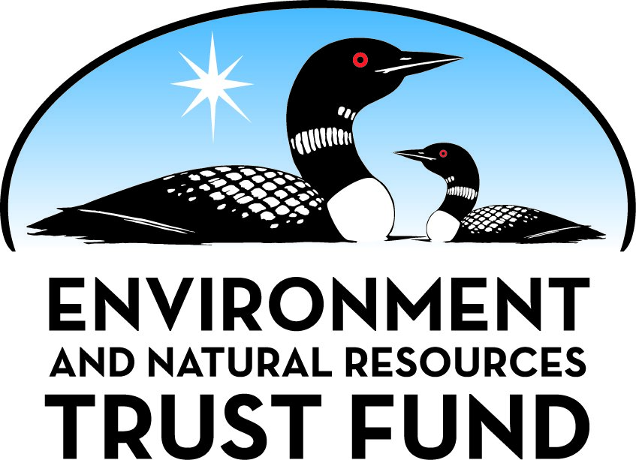

Environment and Natural Resources Trust Fund

M.L. 2025 Final Work Plan

General Information
ID Number: 2025-293
Staff Lead: Tom Dietrich
Date this document submitted to LCCMR: June 5, 2025
Project Title: Echo Bay County Park - Phase 1 Construction
Project Budget: $1,122,000

Project Manager Information
Name: Kevin Fellbaum
Organization: Otter Tail County
Office Telephone: (218) 998-8492
Email: kfellbaum@ottertailcounty.gov
Web Address: https://ottertailcountymn.us/

Project Reporting
Reporting Schedule: March 1 / September 1 of each year.
Project Completion: June 30, 2028
Final Report Due Date: August 14, 2028

Legal Information
Legal Citation: M.L. 2025, First Special Session, Chp. 1, Art. 2, Sec. 2, Subd. 09m
Appropriation Language: $1,122,000 the first year is from the trust fund to the commissioner of natural resources for an agreement with Otter Tail County to construct, in accordance with the Echo Bay County Park Master Plan, access roads, trails, parking, and bathroom facilities that create designated public access and use corridors for outdoor recreation and limit natural resource impacts in Echo Bay County Park.
Appropriation End Date: June 30, 2028

Narrative
Project Summary: Construction of access roads, access trails, parking and bathroom facilities within the County’s recently acquired 165-acre, Echo Bay County Park.
Describe the opportunity or problem your proposal seeks to address. Include any relevant background information.
In 2006, a developer received approval to construct the Preserve at Echo Bay. The 165-acre development was to include 209 housing units, 60 boat slips, a golf course and many other community amenities along the shores of the Pelican River and 261-acre Fish Lake.
The property was eventually acquired and donated to Otter Tail County so the public could enjoy this beautiful 165-acre property, formally named Echo Bay Park. Because of Echo Bay Park’s conservation easement and pristine natural features, we have worked closely with the Minnesota Land Trust to ensure that any park enhancements conform with the conservation easement and increase the public’s understanding of the need for better conservation, preservation and restoration of critical habitats and landscapes.
Since receiving the property in 2021, public access has been limited to foot traffic to protect the habitat, native species and water quality. This project would allow us to expand access to the park as was originally intended while simultaneously protecting its natural features. Increasing free, public outdoor recreational opportunities is a priority for Otter Tail County as identified in our long-range strategic plan. Despite having 1,048 lakes and significant natural resources, they aren’t equally accessible by all community members.
What is your proposed solution to the problem or opportunity discussed above? Introduce us to the work you are seeking funding to do. You will be asked to expand on this proposed solution in Activities & Milestones.
This project will allow us to continue to protect and preserve this beautiful tract of land while simultaneously increasing access to outdoor recreation. LCCMR funding will be used to complete Phase 1 of the Echo Bay Park Master Plan (attached), including the construction of critical infrastructure and amenities at the 165-acre park property on the south side of Fish Lake in Dunn Township, Otter Tail County. More specifically, Phase 1 of the Master Plan includes the construction of one mile of access roads that will bring visitors into the heart of the property. Phase 1 also includes the construction of two parking areas that would hold 60 vehicles along with 4,000 ft of 10 ft wide paved access trails that will provide two different access points to Fish Lake from the parking areas.
While the funding will allow for increased access to outdoor recreation by the public, Phase 1 of the master plan is particularly important for habitat protection. Currently, the public has unfettered access by foot across the property. This funding will allow us to create designated corridors for the public to access the park.
What are the specific project outcomes as they relate to the public purpose of protection, conservation, preservation, and enhancement of the state’s natural resources?
At the completion of this project, Otter Tail County will have constructed 1 mile of paved access road into the property that will connect to two separate parking areas that will hold up to 60 vehicles. Also part of this project will be the creation of 4,000+ ft of 10 ft wide paved access trail that will be ADA compliant and will serve as an access to two separate points of access to Fish Lake. Two Vault Toilets will also be built at the parking lot locations in order to keep to Park Property hygienic and sanitary.

Project Location
What is the best scale for describing where your work will take place?
County(s): Otter Tail
What is the best scale to describe the area impacted by your work?
Region(s): NW, Central,
When will the work impact occur?
During the Project and In the Future

Activities and Milestones

Activity 1: Construction of ECHO Bay Park- Phase 1 Infrastructure
Activity Budget: $1,122,000
Activity Description:
LCCMR Funding will be used to competitively bid and construct one mile of paved access road into the Echo Bay Park property. Construction will also include the construction and paving of two separate parking locations that will hold up to 60+ vehicles. Also included in the project would be the construction of 4000+ ft of 10ft wide paved walking trails that provide access to Fish Lake in several locations along with the construction of vault toilets at each parking area.
Activity Milestones:
Description | Approximate Completion Date
Finalize Engineering, Engineering Review and Permitting | December 31, 2025
Complete Construction Bidding | March 31, 2026
ESA (Checklist and Records Check or Phase 1) (Non-ENRTF) | March 31, 2026
Survey/ESA (Non-ENRTF) | March 31, 2026
Dept of Admin Pre-design Review (Non-ENRTF) | March 31, 2026
Consultation with SHPO (Non-ENRTF) | March 31, 2026
Construction Funds Legally Secured (Non-ENRTF) | March 31, 2026
Notice of Funding Recorded (Non-ENRTF) | March 31, 2026
Initiate Construction | April 30, 2026
Complete Construction of Bituminous Access Roads, Bituminous Access Trail, Bituminous Parking Lots, and Vault Toilets | October 31, 2026
Signage Installed with ENRTF Logo (Non-ENRTF) | December 31, 2026
Open for Intended Use (Non-ENRTF) | December 31, 2026

Project Partners and Collaborators
Name | Organization | Role | Receiving Funds
Sue Steinwell | Minnesota Land Trust | Land Trust Monitor | No
Mike McGarvey | SRF Consulting Group | Master Plan Designer | No

Dissemination
Describe your plans for dissemination, presentation, documentation, or sharing of data, results, samples, physical collections, and other products and how they will follow ENRTF Acknowledgement Requirements and Guidelines.
We will acknowledge the Environment and Natural Resources Trust Fund through use of the trust fund logo on signage within the park and along with trail corridor and through attribution language on project print and electronic media, publications, and other communications and outreach.

Long-Term Implementation and Funding
Describe how the results will be implemented and how any ongoing effort will be funded. If not already addressed as part of the project, how will findings, results, and products developed be implemented after project completion? If additional work is needed, how will this work be funded?
The ability to complete and maintain the project long-term is of upmost importance. Per the attached resolution, the Otter Tail County Board of Commissioners have approved this grant application for the Echo Bay Park Project and the local match.
Once the project is completed, Otter Tail County will assume financial responsibility for the ongoing maintenance and enhancement of the park. The Park will be maintained for biking, walking and other non-motorized uses during spring, summer and fall. In the winter, the Park will be open for winter activities such as cross-country skiing and snowshoeing.

Other ENRTF Appropriations Awarded in the Last Six Years
Name | Appropriation | Amount Awarded
Perham To Pelican Rapids Regional Trail (McDonald Segment) | M.L. 2021, First Special Session, Chp. 6, Art. 6, Sec. 2, Subd. 09a | $2,245,000
Perham to Pelican Rapids Regional Trail (West Segment) | M.L. 2021, First Special Session, Chp. 6, Art. 5, Sec. 2, Subd. 09n | $2,600,000
Phelps Mill Wetland and Prairie Restoration | M.L. 2023, , Chp. 60, Art. 2, Sec. 2, Subd. 08r | $974,000
Maplewood State Park Trail Segment | M.L. 2023, , Chp. 60, Art. 2, Sec. 2, Subd. 09o | $2,514,000

Budget Summary
Category / Name | Subcategory or Type | Description | Purpose | Gen. Ineli gible | % Bene fits | # FTE | Class ified Staff? | $ Amount
Personnel
 |  |  |  |  |  |  | Sub Total | -
Contracts and Services
Contractor selected through Competitive Bid Process | Service Contract | Funds to be used to construct 1 mile of paved access roads, 2 parking lots, 4000+ft of paved 10ft wide trail, 2 vault toilets. |  |  |  | 0 |  | $1,122,000
 |  |  |  |  |  |  | Sub Total | $1,122,000
Equipment, Tools, and Supplies
 |  |  |  |  |  |  | Sub Total | -
Capital Expenditures
 |  |  |  |  |  |  | Sub Total | -
Acquisitions and Stewardship
 |  |  |  |  |  |  | Sub Total | -
Travel In Minnesota
 |  |  |  |  |  |  | Sub Total | -
Travel Outside Minnesota
 |  |  |  |  |  |  | Sub Total | -
Printing and Publication
 |  |  |  |  |  |  | Sub Total | -
Other Expenses
 |  |  |  |  |  |  | Sub Total | -
 |  |  |  |  |  |  | Grand Total | $1,122,000

Classified Staff or Generally Ineligible Expenses
Category/Name | Subcategory or Type | Description | Justification Ineligible Expense or Classified Staff Request

Non ENRTF Funds
Category | Specific Source | Use | Status | $ Amount
State
 |  |  | State Sub Total | -
Non-State
Cash | Otter Tail County | Design Engineering and all Environmental Review and Permitting | Potential | $125,000
Cash | Otter Tail County | Pre-design and design for engineering and all environmental review and permitting costs | Potential | $138,225
Cash | Otter Tail County | Construction engineering, materials testing, and administration | Potential | $75,640
Cash | Otter Tail County | Wetland Mitigation | Potential | $125,000
Cash | Otter Tail County | Master Plan Creation and Public Outreach | Secured | $53,505
 |  |  | Non State Sub Total | $517,370
 |  |  | Funds Total | $517,370

Total Project Cost: $1,639,370
This amount accurately reflects total project cost?
Yes

Attachments

Required Attachments

Visual Component
File:

Alternate Text for Visual Component
The Map provided shows the entire layout of the Echo Bay Park Property, including all four unique project phases of the Master Plan...

Financial Capacity
Title | File
Otter Tail County Audit

Board Resolution or Letter
Title | File
OTC- Echo Bay Phase 1- Board Resolution

Supplemental Attachments

Capital Project Questionnaire, Budget Supplements, Support Letter, Photos, Media, Other
Title | File
Echo Bay Master Plan
Echo Bay Park- HEI Cost Analysis
Budget Addendum_Received post-close
Construction Questionnaire_Received post-close

Difference between Proposal and Work Plan

Describe changes from Proposal to Work Plan Stage
Updated Budget from $1,250,000 to $1,122,000. Added updated County Board Resolution to the attachments tab as requested. Updated project location drop downs to better show project location. Provided a Dissemination explanation. Reviewed status update reporting schedule, no new reporting schedule needed.

Additional Acknowledgements and Conditions:
The following are acknowledgements and conditions beyond those already included in the above workplan:
Do you understand and acknowledge the ENRTF repayment requirements if the use of capital equipment changes?
N/A
Do you understand that travel expenses are only approved if they follow the "Commissioner's Plan" promulgated by the Commissioner of Management of Budget or, for University of Minnesota projects, the University of Minnesota plan?
N/A
Does your project have potential for royalties, copyrights, patents, sale of products and assets, or revenue generation?
No
Do you understand and acknowledge IP and revenue-return and sharing requirements in 116P.10?
N/A
Do you wish to request reinvestment of any revenues into your project instead of returning revenue to the ENRTF?
N/A
Does your project include original, hypothesis-driven research?
No
Does the organization have a fiscal agent for this project?
No
Does your project include the pre-design, design, construction, or renovation of a building, trail, campground, or other fixed capital asset costing $10,000 or more or large-scale stream or wetland restoration?
Yes
Do you propose using an appropriation from the Environment and Natural Resources Trust Fund to conduct a project that provides children's services (as defined in Minnesota Statutes section 299C.61 Subd.7 as "the provision of care, treatment, education, training, instruction, or recreation to children")?
No
Provide the name(s) and organization(s) of additional individuals assisting in the completion of this project:
Nick Leonard, Otter Tail County Deputy County Administrator
Do you understand that a named service contract does not constitute a funder-designated subrecipient or approval of a sole-source contract? In other words, a service contract entity is only approved if it has been selected according to the contracting rules identified in state law and policy for organizations that receive ENRTF funds through direct appropriations, or in the DNR’s reimbursement manual for non-state organizations. These rules may include competitive bidding and prevailing wage requirements
Yes, I understand

