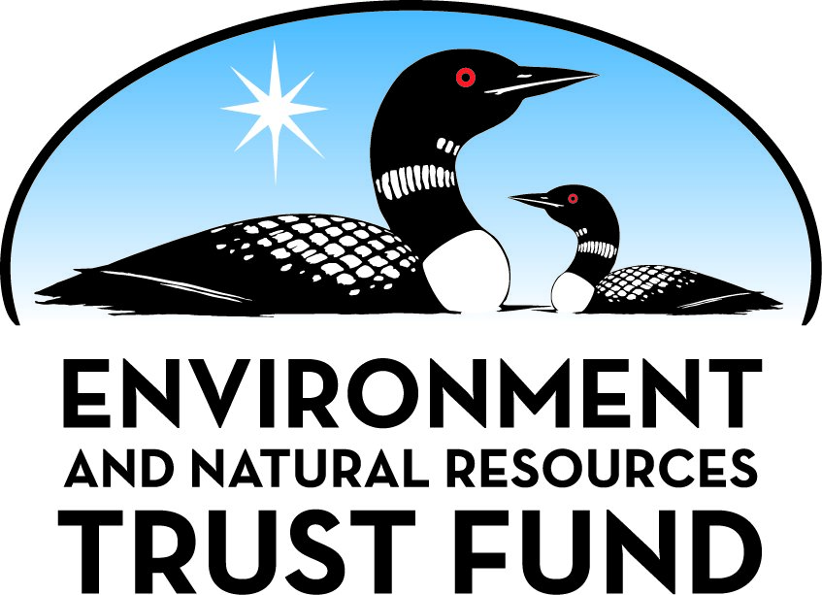

Environment and Natural Resources Trust Fund

M.L. 2025 Final Work Plan

General Information
ID Number: 2025-244
Staff Lead: Lisa Bigaouette
Date this document submitted to LCCMR: June 9, 2025
Project Title: Continued Aggregate Resource Mapping
Project Budget: $621,000

Project Manager Information
Name: Heather Arends
Organization: MN DNR - Lands and Minerals Division
Office Telephone: (651) 219-1808
Email: heather.arends@state.mn.us
Web Address: https://www.dnr.state.mn.us/lands_minerals/index.html

Project Reporting
Reporting Schedule: March 1 / September 1 of each year.
Project Completion: June 30, 2028
Final Report Due Date: August 14, 2028

Legal Information
Legal Citation: M.L. 2025, First Special Session, Chp. 1, Art. 2, Sec. 2, Subd. 03y
Appropriation Language: $621,000 the first year is from the trust fund to the commissioner of natural resources to map the aggregate resource potential in the state of Minnesota and to make the information available in print and electronic format to local units of government to support informed land-use decisions and resource conservation.
Appropriation End Date: June 30, 2028

Narrative
Project Summary: DNR aggregate resource datasets provide vital information to local governments to support informed land-use decisions and resource conservation. This proposal will complete and start projects to equal about 4-6 counties.
Describe the opportunity or problem your proposal seeks to address. Include any relevant background information.
Aggregate resource maps and databases play a crucial role in supporting conservation of natural resources and land-use decision-making. There is historic demand for aggregate resources driven by unprecedented funding for transportation and recreation infrastructure. In the past five years, twelve counties have passed resolutions requesting mapping, which has doubled the DNR waitlist to include 22 counties wanting this information. Issues driving the need for aggregate resource maps include a shortage of septic sand, which is necessary to protect groundwater; new MNDOT initiatives to lower the carbon footprint for transpiration projects, which requires access to local sources of aggregate in order to minimize green house gas emissions; and better management of competing resources to direct development onto less sensitive areas.
Maps have been competed for 30 out of 87 counties in Minnesota with two counties in progress (St. Louis and Yellow Medicine counties). This ongoing project is a continued effort to provide data and maps statewide.
What is your proposed solution to the problem or opportunity discussed above? Introduce us to the work you are seeking funding to do. You will be asked to expand on this proposed solution in Activities & Milestones.
Aggregate resource maps inform decisions about complex resource management and conservation issues. This information is frequently used to demonstrate alternative sources of aggregate when protecting high value conservation areas and enables decision-makers to spread the burden of development. In this proposal, the DNR’s Aggregate Resource Mapping Program (ARMP) will identify and characterize aggregate resources to produce final maps and datasets, as well as compile information to equal about 4-6 counties. Final datasets will be widely available so that all stakeholders are better informed to protect, conserve, preserve, and enhance the state’s natural resources. The County Board of Commissioners of every county on the ARMP waitlist has passed a resolution requesting this work.
ARMP uses a combination of remote sensing interpretation, geologic fieldwork, and GIS analysis to inventory aggregate resources and the status of reclamation for gravel pits. Aggregate maps and associated GIS data can be layered with other natural resource layers to inform decisions on resource conservation and protection, infrastructure projects, and sustainable community development.
What are the specific project outcomes as they relate to the public purpose of protection, conservation, preservation, and enhancement of the state’s natural resources?
This proposal will complete current projects and start new projects to equal 4-6 complete counties with the following outcomes:
1. A complete survey of active, inactive and abandoned aggregate mines, which will aid in reclamation efforts (abandoned mines can be a source of storm water runoff and pollution from illegal dumping).
2. Complete any unfinished ENRTF supported Aggregate Mapping projects in progress started with 2021 appropriations.
3. Provide technical data and maps that is accessible to the public, easily understood by non-geologists, and shows the distribution of sand, gravel, and crushed stone resources compiled at 1:50,000 scale.

Project Location
What is the best scale for describing where your work will take place?
Statewide
What is the best scale to describe the area impacted by your work?
Statewide
When will the work impact occur?
During the Project and In the Future

Activities and Milestones

Activity 1: Initiate or complete 4-6 aggregate resource maps
Activity Budget: $621,000
Activity Description:
DNR geologists use county-scale geologic mapping techniques to identify sand, gravel, and crushed stone resources and characterize their relative quality. This information is foundational to natural resource stewardship and is used by local governments and the public. The aggregate mapping process includes:
1. Compiling and evaluating gravel pit data, historic geologic information, GIS datasets, and remotely sensed layers (e.g. LiDAR).
2. Conducting fieldwork to describe and analyze deposits, survey gravel pits and bedrock quarries, and collect geologic observations.
3. Drafting aggregate resource potential maps based on office and field-based data, and facilitating technical peer review.
4. Publishing county-specific data products including free GIS data packages, countywide PDF maps, and interactive aggregate map services.
5. Co-sponsoring a workshop with local partners to educate users how to apply project data to local resource stewardship, while continuing to provide ongoing technical support.
DNR’s Aggregate Resource Mapping Program coordinates with Minnesota Geologic Survey and Minnesota Department of Transportation, as well as local partners, to produce geologically accurate and publicly accessible maps and information.
Activity Milestones:
Description | Approximate Completion Date
Conduct fieldwork, collect field observations, inventory active, inactive, and reclaimed pits/quarries, and collect samples. | December 31, 2027
Digitize draft lines and mapping units within mapped counties. | May 31, 2028
Compile data for 4-6 counties | June 30, 2028
Complete and publish aggregate resource maps for at least three counties, depending on size. | June 30, 2028

Dissemination
Describe your plans for dissemination, presentation, documentation, or sharing of data, results, samples, physical collections, and other products and how they will follow ENRTF Acknowledgement Requirements and Guidelines.
Every aggregate map is produced in portable document format (PDF), an interactive web map, as geographic information system files (GIS), and in printed form. The digital files are available to download from the Department of Natural Resources as well as the Minnesota Geospatial Commons. Each completed county as its own webpage that links to the above mentioned formats of dissemination: https://www.dnr.state.mn.us/lands_minerals/aggregate_maps/index.html. Each project culminates in a workshop hosted by the DNR for county staff, and any other interested parties; and a presentation to the county commissioners at a regularly scheduled board meeting. At these workshops, the products are described, access to the products is explained, and examples of applications of the products to common resource management situations are demonstrated. Printed copies are shared with the county, who in turn can distribute them to libraries, schools, townships, and other agencies. Any member of the public may request a map, free of charge.
The Minnesota Environment and Natural Resources Trust Fund (ENRTF) will be acknowledged through use of the trust fund logo or attribution language on project print and electronic media, publications, signage, and other communications per the ENRTF Acknowledgement Guidelines.

Long-Term Implementation and Funding
Describe how the results will be implemented and how any ongoing effort will be funded. If not already addressed as part of the project, how will findings, results, and products developed be implemented after project completion? If additional work is needed, how will this work be funded?
As provided by MN Statute 84.94, counties who receive this data must consider the information in their land use decision. This work will be undertaken by county and township planning and zoning authorities. No additional funding will be required.

Other ENRTF Appropriations Awarded in the Last Six Years
Name | Appropriation | Amount Awarded
Accelerated Aggregate Resource Mapping | M.L. 2019, First Special Session, Chp. 4, Art. 2, Sec. 2, Subd. 03h | $700,000
Aggregate Resource Mapping | M.L. 2022, , Chp. 94, Art. , Sec. 2, Subd. 10a | $500,000

Budget Summary
Category / Name | Subcategory or Type | Description | Purpose | Gen. Ineli gible | % Bene fits | # FTE | Class ified Staff? | $ Amount
Personnel
Geologist 1 |  | Project Geologist |  |  | 28% | 3 |  | $270,000
Geologist 2 |  | Project Geologist |  |  | 28% | 3 |  | $270,000
 |  |  |  |  |  |  | Sub Total | $540,000
Contracts and Services
 |  |  |  |  |  |  | Sub Total | -
Equipment, Tools, and Supplies
 | Equipment | Field equipment such as augers, shovels, safety equipment and related items. | Equipment needed to conduct geologic fieldwork. |  |  |  |  | $2,000
 | Tools and Supplies | Supplies includes fieldnote books, field clothing and boots, sample bags | Supplies for conducting fieldwork. |  |  |  |  | $2,000
 |  |  |  |  |  |  | Sub Total | $4,000
Capital Expenditures
 |  |  |  |  |  |  | Sub Total | -
Acquisitions and Stewardship
 |  |  |  |  |  |  | Sub Total | -
Travel In Minnesota
 | Miles/ Meals/ Lodging | Lodging, meals, mileage for 70 days | Travel expenses for MN travel related to field survey in Activities 1 & 2. Travel expenses are subject to State of MN labor agreements |  |  |  |  | $13,450
 |  |  |  |  |  |  | Sub Total | $13,450
Travel Outside Minnesota
 |  |  |  |  |  |  | Sub Total | -
Printing and Publication
 |  |  |  |  |  |  | Sub Total | -
Other Expenses
 |  | Direct and Necessary Cost - Safety Support | To support DNR internal services associated with projects |  |  |  |  | $2,028
 |  | Direct and Necessary Cost - People Support | To support DNR internal services associated with projects |  |  |  |  | $14,448
 |  | Direct and Necessary Cost - Financial Support | To support DNR internal services associated with projects |  |  |  |  | $5,393
 |  | Direct and Necessary Cost - Communication Support | To support DNR internal services associated with projects |  |  |  |  | $1,528
 |  | Direct and Necessary Cost - IT support | To support DNR internal services associated with projects |  |  |  |  | $39,016
 |  | Direct and Necessary Cost - Planning Support | To support DNR internal services associated with projects |  |  |  |  | $1,137
 |  |  |  |  |  |  | Sub Total | $63,550
 |  |  |  |  |  |  | Grand Total | $621,000

Classified Staff or Generally Ineligible Expenses
Category/Name | Subcategory or Type | Description | Justification Ineligible Expense or Classified Staff Request

Non ENRTF Funds
Category | Specific Source | Use | Status | $ Amount
State
Cash | General Fund | Salary for classified employee | Potential | $200,000
 |  |  | State Sub Total | $200,000
Non-State
 |  |  | Non State Sub Total | -
 |  |  | Funds Total | $200,000

Total Project Cost: $821,000
This amount accurately reflects total project cost?
Yes

Attachments

Required Attachments

Visual Component
File:

Alternate Text for Visual Component
Map showing the current status of aggregate resource mapping in the state, with 30 completed counties, 22 counties that have requested this information, and 2 counties in progress....

Difference between Proposal and Work Plan

Describe changes from Proposal to Work Plan Stage
Lowered staffing; changed budget to approved funding; the next counties may be large, so modified language to indicate size may be a factor for final results.

Additional Acknowledgements and Conditions:
The following are acknowledgements and conditions beyond those already included in the above workplan:
Do you understand and acknowledge the ENRTF repayment requirements if the use of capital equipment changes?
N/A
Do you understand that travel expenses are only approved if they follow the "Commissioner's Plan" promulgated by the Commissioner of Management of Budget or, for University of Minnesota projects, the University of Minnesota plan?
Yes, I understand the Commissioner's Plan applies.
Does your project have potential for royalties, copyrights, patents, sale of products and assets, or revenue generation?
No
Do you understand and acknowledge IP and revenue-return and sharing requirements in 116P.10?
N/A
Do you wish to request reinvestment of any revenues into your project instead of returning revenue to the ENRTF?
N/A
Does your project include original, hypothesis-driven research?
No
Does the organization have a fiscal agent for this project?
No
Does your project include the pre-design, design, construction, or renovation of a building, trail, campground, or other fixed capital asset costing $10,000 or more or large-scale stream or wetland restoration?
No
Do you propose using an appropriation from the Environment and Natural Resources Trust Fund to conduct a project that provides children's services (as defined in Minnesota Statutes section 299C.61 Subd.7 as "the provision of care, treatment, education, training, instruction, or recreation to children")?
No
Provide the name(s) and organization(s) of additional individuals assisting in the completion of this project:
Jason Tidemann, Department of Natural Resources
Do you understand that a named service contract does not constitute a funder-designated subrecipient or approval of a sole-source contract? In other words, a service contract entity is only approved if it has been selected according to the contracting rules identified in state law and policy for organizations that receive ENRTF funds through direct appropriations, or in the DNR’s reimbursement manual for non-state organizations. These rules may include competitive bidding and prevailing wage requirements
N/A

