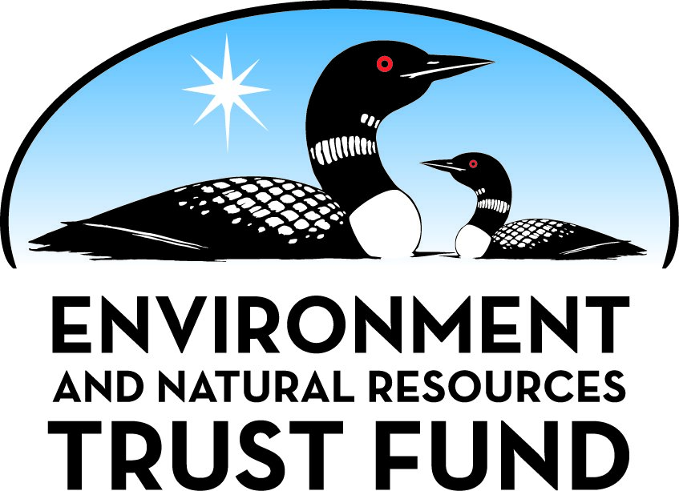

Environment and Natural Resources Trust Fund

M.L. 2025 Final Work Plan

General Information
ID Number: 2025-239
Staff Lead: Noah Fribley
Date this document submitted to LCCMR: June 11, 2025
Project Title: Enhancing the Value of Minnesota Public Grasslands
Project Budget: $390,000

Project Manager Information
Name: Eric Mousel
Organization: U of MN - College of Food, Agricultural and Natural Resource Sciences
Office Telephone: (218) 513-0781
Email: emmousel@umn.edu
Web Address: https://cfans.umn.edu/

Project Reporting
Reporting Schedule: March 1 / September 1 of each year.
Project Completion: June 30, 2028
Final Report Due Date: August 14, 2028

Legal Information
Legal Citation: M.L. 2025, First Special Session, Chp. 1, Art. 2, Sec. 2, Subd. 03w
Appropriation Language: $390,000 the first year is from the trust fund to the Board of Regents of the University of Minnesota to evaluate a combination of prescribed fire, brush mowing, and targeted conservation grazing to develop ready-to-use management strategies for public land managers to mitigate woody species encroachment and increase biodiversity and carbon sequestration in public grasslands.
Appropriation End Date: June 30, 2028

Narrative
Project Summary: Evaluate prescribed fire, brush mowing and targeted conservation grazing to develop ready-to-use management strategies for public lands managers to mitigate woody species encroachment in public grasslands.
Describe the opportunity or problem your proposal seeks to address. Include any relevant background information.
Greater than 95% of Minnesota’s prairies have been lost to the plow and development. Many of the remaining acres of native and restored grasslands have been degraded from lack of fire and the spread of invasive woody species. Woody plant (i.e. brush and trees) encroachment in grasslands is a hallmark trait of climate change but tends to be exacerbated by improper management. The Tallgrass Aspen Parkland (TAP) is an ecoregion located in southeastern Manitoba and northwestern Minnesota. This boreal-grassland transition zone is a zone of constant competition and tension as prairie and woodlands struggle to overtake each other within the parkland. The Caribou Wildlife Management Area (CWMA), located within the TAP in northwestern Minnesota has experienced significant levels of brush encroachment into their respective grassland components resulting in reduced wildlife and pollinator habitat quality, shifts in ecological feedback loops and loss of biodiversity. The objectives of this study will be to evaluate the effect of high density grazing following prescribed fire and/or mechanical brush removal on reducing woody species density. The results will create more sustainable management practices that promote vegetation diversity, improve soil health and benefit the environment on public lands for the benefit of all Minnesotans.
What is your proposed solution to the problem or opportunity discussed above? Introduce us to the work you are seeking funding to do. You will be asked to expand on this proposed solution in Activities & Milestones.
We propose to conduct field trials at CWMA and CWR to evaluate the effect of different combinations of prescribed burning, mechanical brush mowing and livestock grazing on mitigation of brush species encroachment into grassland, vegetation species diversity, and carbon sequestration. This project aims to develop ready-to-use landscape management systems that successfully and consistently allow MNDNR managers to mitigate brush encroachment in grasslands, increase species diversity through disturbance and increase carbon sequestration on public lands in the northern half of the state.
What are the specific project outcomes as they relate to the public purpose of protection, conservation, preservation, and enhancement of the state’s natural resources?
This project aims to evaluate applied field research to advance the sustainable management of public lands management in MN. The outcomes of the project include mitigating brush encroachment in grasslands, increasing species diversity through disturbance and helping to mitigate atmospheric greenhouse gas emissions by increasing carbon sequestration on public lands. These outcomes will enhance the experience of stakeholders on public lands, particularly MNDNR Wildlife Management Areas by promoting sustainable management systems that can be enjoyed by all Minnesotans for generations to come.

Project Location
What is the best scale for describing where your work will take place?
Region(s): NW
What is the best scale to describe the area impacted by your work?
Statewide
When will the work impact occur?
During the Project and In the Future

Activities and Milestones

Activity 1: Brush encroachment mitigation strategies
Activity Budget: $286,000
Activity Description:
Field trials will be conducted at CWMA and CWR near Lancaster, MN. A prescribed fire will be conducted by MN DNR burn crew on both sites. Following prescribed fire, grassland areas will be brush-mowed to remove woody species not burned in the fire. Cattle from a neighboring ranch will be used to graze regrowth to maintain vegetation balance.
Activity Milestones:
Description | Approximate Completion Date
Conduct initial brush density evaluation on 2,560 acres | May 31, 2026
Prescribed burn on 2,240 acres | May 31, 2026
Conduct mid-experiment brush density evaluation on 2,560 acres | October 31, 2026
Graze 320 acres in June only | June 30, 2027
Graze 640 acres in July only | July 31, 2027
Graze 640 acres in August only | August 31, 2027
Graze 1,920 total acres; 320 burned but not grazed | September 30, 2027
Graze 320 in June and September | September 30, 2027
Conduct final brush density evaluation on 2560 acres | October 31, 2027

Activity 2: Vegetation diversity evaluation
Activity Budget: $50,000
Activity Description:
Vegetation diversity indices will be measured before trial establishment and again after application of land management treatments. From this we will be able to determine the effect of these management tool combinations on changes in vegetation diversity.
Activity Milestones:
Description | Approximate Completion Date
Conduct initial vegetation diversity assessment on 2,560 acre prior to application of treatments | October 31, 2025
Conduct initial habitat quality and species richness survey on 2,560 acres | October 31, 2025
Conduct mid-experiment survey of vegetation diversity, habitat quality and species richness | October 31, 2026
Application of brush encroachment mitigation strategies outlined in Activity 1 | September 30, 2027
Conduct final assessment of vegetation diversity, habitat quality and species richness | October 31, 2027

Activity 3: Carbon sequestration
Activity Budget: $48,000
Activity Description:
Field trials established for brush encroachment mitigation will be used for this purpose. Soil carbon stocks will be measured before trial establishment and again after application of land management treatments. From this we will be able to determine the effect of these management tool combinations on carbon sequestration potential and total carbon stocks.
Activity Milestones:
Description | Approximate Completion Date
Conduct initial soil survey and grid sample soils for Carbon fractionation analysis | October 31, 2025
Conduct mid-experiment grid sampling for C fraction analysis on 2,560 acres | October 31, 2026
Application of brush encroachment mitigation treatments as outlined in Activity 1 | September 30, 2027
Conduct final grid sampling for C analysis on 2,560 acres | October 31, 2027

Activity 4: Outreach and Dissemination
Activity Budget: $6,000
Activity Description:
Conduct outreach event to disseminate project results to Agency field staff, develop three videos outlining project justification, initiation and results. Project will generate 1 master's degree thesis and 1 peer-review journal manuscript. ENRTF will be featured as the project funder in all three social media videos and in the in-person outreach event. Additionally, ENRTF will be acknowledged in the graduate thesis and the peer-reviewed manuscript.
Activity Milestones:
Description | Approximate Completion Date
Develop initial project outline video for publication on social media platforms. | September 30, 2025
Develop treatment application video for project for publication on social media platforms. | September 30, 2026
Complete and submit annual reports to LCCMR in 2026 and 2027. | June 30, 2027
Completion of one Master's Degree thesis | May 31, 2028
Develop project results video for publication on social media platforms. | June 30, 2028
Conduct outreach event to deliver project results to Agency and NGO land managers. | June 30, 2028
Completion of one peer-reviewed journal manuscript | June 30, 2028
Complete final report to LCCMR | June 30, 2028

Project Partners and Collaborators
Name | Organization | Role | Receiving Funds
Jason Wollin | MN DNR | Collaborator | No
Jacob Anderson | The Nature Conservancy | Collaborator | No

Dissemination
Describe your plans for dissemination, presentation, documentation, or sharing of data, results, samples, physical collections, and other products and how they will follow ENRTF Acknowledgement Requirements and Guidelines.
This project includes direct participation of MN DNR and The Nature Conservancy as well as input from focus groups including U.S. Fish and Wildlife Services, USDA Natural Resource Conservation Service, Ducks Unlimited, and Pheasants Forever. During and at the conclusion of the project, dissemination of project progress to LCCMR will occur through submitted progress reports. Annual progress and results will be distributed to federal, state and private land managers through in-person field days and workshops as well as inter-agency discussions and symposia. External reports will acknowledge ENTRF through logo display and text. The project is expected to yield at least two scientific manuscripts published in academic journals; ENRTF will be acknowledged in the manuscripts as allowed by journal standards. Development of conventional and social media content during and at the conclusion of the project to demonstrate the importance of the project to the general public, the impact of the results on Minnesota grasslands, and the investment made by ENRTF in the project for the benefit of all Minnesotans. ENRTF will be acknowledged in all social posts and videos through logo display, tagging and text where appropriate. Research results will be made available in real-time to MN DNR partners and all data will be stored in the UMN Conservatorium for public access and use. Results ultimately will be used to enhance the tools available to Minnesota public and private land managers to conserve and improve the value of Minnesota grasslands.

Long-Term Implementation and Funding
Describe how the results will be implemented and how any ongoing effort will be funded. If not already addressed as part of the project, how will findings, results, and products developed be implemented after project completion? If additional work is needed, how will this work be funded?
Results from this proposal will support training programs for public lands managers and public stakeholders to understand the necessity of applying land management tools on public lands to sustain their utility into the future. This project will provide information for policy makers to develop legislation and agency rule-making that supports environmentally sound management techniques for enhancing the experience of stakeholders in their enjoyment of public lands. Previous, current and future work have been supported by state and federal agencies and the U of M. Federal and state agencies will be the primary targets for funding for future work as needed.

Budget Summary
Category / Name | Subcategory or Type | Description | Purpose | Gen. Ineli gible | % Bene fits | # FTE | Class ified Staff? | $ Amount
Personnel
Principal investigator |  | Management of project implementation and execution |  |  | 37.1% | 0.6 |  | $81,720
Masters level graduate student |  | Oversee field trials and support data collection |  |  | 25.1% | 3 |  | $127,005
 |  |  |  |  |  |  | Sub Total | $208,725
Contracts and Services
TBD | Service Contract | mowing brush at research sites |  |  |  | 0.25 |  | $125,000
AgVise Laboratories, Benson, MN | Service Contract | Laboratory fees for soil C lab analysis |  |  |  | 0.25 |  | $21,000
 |  |  |  |  |  |  | Sub Total | $146,000
Equipment, Tools, and Supplies
 | Tools and Supplies | Vegetation sampling supplies (4 sets of clippers, collection bags) | Collecting vegetation data |  |  |  |  | $1,500
 | Tools and Supplies | Soil probes, containers and storage (2 soil probes, soil boxes, storage containers) | Collecting soil samples for C analysis |  |  |  |  | $1,500
 | Tools and Supplies | GPS supplies (2 units) | Permanent, non-physical marking of data collection points |  |  |  |  | $1,050
 |  |  |  |  |  |  | Sub Total | $4,050
Capital Expenditures
 |  |  |  |  |  |  | Sub Total | -
Acquisitions and Stewardship
 |  |  |  |  |  |  | Sub Total | -
Travel In Minnesota
 | Miles/ Meals/ Lodging | Trips from Grand Rapids to research sites at Caribou WMA in NW MN (6 per year, 3-4 people)) | Establish field experiments, data collection and present results as required by LCCMR |  |  |  |  | $19,225
 | Miles/ Meals/ Lodging | Once at the research site, an ATV must be used to move between sites. A daily ATV lease per trip will be required. 6 trips in 2025, 6 trips in 2026 and 6 trips in 2027. | Daily ATV lease to move between sites at the CWMA for project initiation and data collection. |  |  |  |  | $6,000
 |  |  |  |  |  |  | Sub Total | $25,225
Travel Outside Minnesota
 |  |  |  |  |  |  | Sub Total | -
Printing and Publication
 | Printing | Printing of reports and bulletins | Materials for concurrent and post-project outreach events |  |  |  |  | $2,500
 | Publication | Publication of scientific manuscripts (2 expected) | Cost of publication of scientific findings |  |  |  |  | $3,500
 |  |  |  |  |  |  | Sub Total | $6,000
Other Expenses
 |  |  |  |  |  |  | Sub Total | -
 |  |  |  |  |  |  | Grand Total | $390,000

Classified Staff or Generally Ineligible Expenses
Category/Name | Subcategory or Type | Description | Justification Ineligible Expense or Classified Staff Request

Non ENRTF Funds
Category | Specific Source | Use | Status | $ Amount
State
 |  |  | State Sub Total | -
Non-State
 |  |  | Non State Sub Total | -
 |  |  | Funds Total | -

Total Project Cost: $390,000
This amount accurately reflects total project cost?
Yes

Attachments

Required Attachments

Visual Component
File:

Alternate Text for Visual Component
Aerial photo of proposed research site at Caribou WMA and Carbiou Woodland Reserve in NW MN...

Supplemental Attachments

Capital Project Questionnaire, Budget Supplements, Support Letter, Photos, Media, Other
Title | File
UMN Authorization Letter
Support Letter - The Nature Conservancy
MN GLCA

Difference between Proposal and Work Plan

Describe changes from Proposal to Work Plan Stage
None.

Additional Acknowledgements and Conditions:
The following are acknowledgements and conditions beyond those already included in the above workplan:
Do you understand and acknowledge the ENRTF repayment requirements if the use of capital equipment changes?
N/A
Do you understand that travel expenses are only approved if they follow the "Commissioner's Plan" promulgated by the Commissioner of Management of Budget or, for University of Minnesota projects, the University of Minnesota plan?
Yes, I understand the UMN Policy on travel applies.
Does your project have potential for royalties, copyrights, patents, sale of products and assets, or revenue generation?
No
Do you understand and acknowledge IP and revenue-return and sharing requirements in 116P.10?
N/A
Do you wish to request reinvestment of any revenues into your project instead of returning revenue to the ENRTF?
N/A
Does your project include original, hypothesis-driven research?
Yes
Does the organization have a fiscal agent for this project?
Yes, Sponsored Projects Administration
Does your project include the pre-design, design, construction, or renovation of a building, trail, campground, or other fixed capital asset costing $10,000 or more or large-scale stream or wetland restoration?
No
Do you propose using an appropriation from the Environment and Natural Resources Trust Fund to conduct a project that provides children's services (as defined in Minnesota Statutes section 299C.61 Subd.7 as "the provision of care, treatment, education, training, instruction, or recreation to children")?
No
Provide the name(s) and organization(s) of additional individuals assisting in the completion of this project:
Kelsey Grachek
Do you understand that a named service contract does not constitute a funder-designated subrecipient or approval of a sole-source contract? In other words, a service contract entity is only approved if it has been selected according to the contracting rules identified in state law and policy for organizations that receive ENRTF funds through direct appropriations, or in the DNR’s reimbursement manual for non-state organizations. These rules may include competitive bidding and prevailing wage requirements
Yes, I understand

