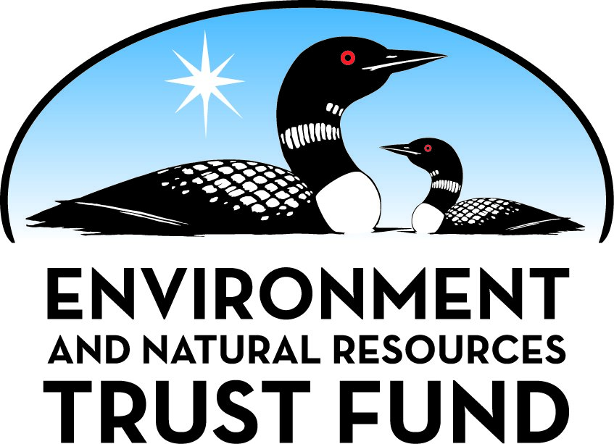

Environment and Natural Resources Trust Fund

M.L. 2025 Final Work Plan

General Information
ID Number: 2025-233
Staff Lead: Noah Fribley
Date this document submitted to LCCMR: June 17, 2025
Project Title: Pilot Water Budget Framework for Managing Water Withdrawals
Project Budget: $198,000

Project Manager Information
Name: John Nieber
Organization: U of MN - College of Food, Agricultural and Natural Resource Sciences
Office Telephone: (612) 625-6724
Email: nieber@umn.edu
Web Address: https://cfans.umn.edu/

Project Reporting
Reporting Schedule: March 1 / September 1 of each year.
Project Completion: June 30, 2026
Final Report Due Date: August 14, 2026

Legal Information
Legal Citation: M.L. 2025, First Special Session, Chp. 1, Art. 2, Sec. 2, Subd. 04s
Appropriation Language: $198,000 the first year is from the trust fund to the Board of Regents of the University of Minnesota to develop a pilot water budget framework to identify sensitive areas in Minnesota where net water withdrawals have a significant impact on surface water and groundwater.
Appropriation End Date: June 30, 2028

Narrative
Project Summary: This project will develop a pilot water budget framework to identify sensitive areas in Minnesota where net water withdrawals have a significant impact on surface and ground water.
Describe the opportunity or problem your proposal seeks to address. Include any relevant background information.
Managing water availability for human use is becoming increasingly difficult due to the confluence of increased public water demand and the variability of weather induced by climate change. Increased public water demand can result from increased population, increased agricultural water demand from more acreage or a move to increased irrigation, while climate change can cause lower water availability during dry periods from decreased precipitation and increased evaporation due to increased temperatures.
Water availability is shared and needs to be managed accordingly. However, in Minnesota, it is managed by many state agencies with no clear management framework and a bias towards water quality. Areas with mild water shortages should get more resources for restoration and areas with severe water shortages might need to be restricted to current users only. Water-use data can be better organized and analysis tools can be developed to prioritize watersheds and groundwater zones, so that those areas most affected by water deficits get the most attention.
We see the need to develop a framework for water withdrawal management to systematically identify critical areas where the streamflow or groundwater has been depleted. Low streamflow or groundwater level is an indicator of excessive surface or groundwater withdrawals.
What is your proposed solution to the problem or opportunity discussed above? Introduce us to the work you are seeking funding to do. You will be asked to expand on this proposed solution in Activities & Milestones.
We propose developing a pilot water budget framework for managing water withdrawals in Minnesota. The work will identify critical areas where the natural supply of water has been depleted. This approach will be based on the framework outlined in the Massachusetts Sustainable Watershed Initiative and will provide the impetus for a new framework for Minnesota.
A water budget approach is a relatively simple accounting of human-based water withdrawals and discharges relative to the natural hydrology. The yardstick for measuring net withdrawal impact is typically the median monthly natural streamflow or annual natural recharge rate. All human inputs and outputs of water for each area are quantified and the net human impact determined. The net human withdrawal rate is then compared to the estimated natural rate for each area to determine the relative human impact.
We will evaluate a select number of areas to determine the best way to implement the water budgets method in Minnesota. The work will evaluate the availability of water withdrawal data, the size of the area, and the definition of the correct natural recharge rate for determining the relative impact (percent). This new water withdrawal framework could unify the efforts of the state agencies managing water.
What are the specific project outcomes as they relate to the public purpose of protection, conservation, preservation, and enhancement of the state’s natural resources?
Water budgets can offer helpful guidance on short and long-term decisions about the use of water. The proposed framework will identify areas with water deficits that warrant further planning and action by communities to ensure the sustainability of their invaluable water resources. Communities will be able to better understand the impact of their withdrawals and discharges on specific watersheds or groundwater zones. As a planning and regulatory tool, communities could consider the impact of wells and wastewater discharges, find better water sources, and seek ways to improve the overall natural balance of their water resources.

Project Location
What is the best scale for describing where your work will take place?
Statewide
What is the best scale to describe the area impacted by your work?
Statewide
When will the work impact occur?
In the Future

Activities and Milestones

Activity 1: Develop a Water Budget Framework for Managing Surface Water
Activity Budget: $85,000
Activity Description:
Our Team will work define three study watersheds with predominantly urban, agricultural, and forested land use. Because cumulative effects are important for streamflow impacts, we will create a cumulative watershed for the areas upstream of the selected watersheds. These cumulative watersheds will be used to calculate the net withdrawals and median streamflow values.
The data need for this project will include monthly withdrawals, monthly discharges, private well/septic areas, and forested/irrigated areas. Time lag between the withdrawal/discharge location and the river can be accommodated approximately with the USGS Stream Depletion tool.
Natural streamflow will be estimated using a USGS publication (2023) on low flow statistics in Minnesota. We will evaluate various natural low flow statistics for a flow metric or yardstick. The most likely metric will be the monthly median values of daily streamflow. Cumulative net withdrawal divided by cumulative natural streamflow will be the estimate of relative impact (%). Relative impact will be summarized for the three subwatersheds.
The relative impact results will be evaluated for water management utility. We will also evaluate how climate change might influence this approach, using information from a soon-to-be funded LCCMR project on the effect of climate change on streamflow (2024-213).
Activity Milestones:
Description | Approximate Completion Date
Define study watersheds, data needed and metrics | August 31, 2025
Acquire data needed and process for each watershed | September 30, 2025
Calculations for study watersheds | November 30, 2025

Activity 2: Develop a Water Budget Framework for Managing Groundwater
Activity Budget: $85,000
Activity Description:
Our Team will work define up to three study groundwater areas with predominantly urban, agricultural, and forested land use. Because cumulative effects are not important for groundwater storage, we will use the actual groundwater area for this analysis. These areas will be used to calculate the net withdrawals and average recharge rate.
As in Task 1, the data need will include monthly withdrawals, monthly discharges, private well/septic areas, and forested/irrigated areas. We will also evaluate various estimates of natural recharge to develop a recharge metric or yardstick. The most likely metric will be the average annual recharge rate. Cumulative net withdrawal divided by cumulative natural recharge rate will be the estimate of relative impact (%). Relative impact will be summarized for the three groundwater areas.
The relative impact results will be evaluated for water management utility. We will also evaluate how climate change might influence this approach. We will utilize recent work at UMN (by Harsh Anurag, now at Geosyntec) to evaluate the effect of climate change on recharge.
Activity Milestones:
Description | Approximate Completion Date
Define study groundwater zones, data needed and metrics | December 31, 2025
Acquire data needed and process for each groundwater zone. | January 31, 2026
Calculations for study groundwater zones | March 31, 2026

Activity 3: Project Management and Reporting
Activity Budget: $28,000
Activity Description:
The team will establish a Technical Advisory Committee (TAC) with experts from Minnesota Department of Health (MDH), Minnesota Pollution Control Agency (MPCA), and Minnesota Department of Natural Resources. The TAC will meet every three months while the full project team will meet monthly. Leveraging our existing relationships, we will establish a stakeholder group from cities, counties, watershed districts/organizations, and non-profits.
A draft and final report will provide documentation of the project to clearly explain the proposed pilot framework. Following the completion of the final report, our Team will develop draft and final training slides, then conduct a one-hour workshop (recorded) on the proposed water management framework.
Our team will provide periodic updates to the LCCMR as contracted. The updates will include documentation of the TAC meetings, status of the tasks, discussion of unexpected issues and resolutions, and any results to date.
Activity Milestones:
Description | Approximate Completion Date
Finalize proposed TAC members | August 31, 2025
Draft and final report | May 31, 2026
Present a one-hour training webinar | June 30, 2026

Project Partners and Collaborators
Name | Organization | Role | Receiving Funds
John Nieber | University of Minnesota | Project Manager | Yes
Nigel Pickering | Geosyntec Consultants, Inc. | Project Consultant | Yes
State Staff | State Agencies | TAC Members (added in Activity 3) | No

Dissemination
Describe your plans for dissemination, presentation, documentation, or sharing of data, results, samples, physical collections, and other products and how they will follow ENRTF Acknowledgement Requirements and Guidelines.
The results of this project will be disseminated by 1) interacting closely with practitioners in our TAC; and 2) presenting the results at local conferences including the: Minnesota Water Resources Conference, Minnesota Watersheds Conference, and the Central States Water Environment Association (CSWEA) Conference.
The Minnesota Environment and Natural Resources Trust Fund (ENRTF) will be acknowledged through use of the trust fund logo or attribution language on project print and electronic media, publications, signage, and other communications per the ENRTF Acknowledgement Guidelines.

Long-Term Implementation and Funding
Describe how the results will be implemented and how any ongoing effort will be funded. If not already addressed as part of the project, how will findings, results, and products developed be implemented after project completion? If additional work is needed, how will this work be funded?
Water availability is shared but in Minnesota it is managed by many state agencies with no clear framework. This pilot water budget framework will provide a catalyst for future water quantity management and bring together the many state agencies that are currently involved with water management in Minnesota. It will also help define the data needs of the framework, the datasets needed for efficient tracking of water withdrawal impacts, and the best approach for estimating the impacts to surface water and groundwater. With future LCCMR funding, this pilot framework could be extended to the entire state.

Other ENRTF Appropriations Awarded in the Last Six Years
Name | Appropriation | Amount Awarded
Setting Realistic Nitrate Reduction Goals in Southeast Minnesota | M.L. 2019, First Special Session, Chp. 4, Art. 2, Sec. 2, Subd. 04m | $350,000

Budget Summary
Category / Name | Subcategory or Type | Description | Purpose | Gen. Ineli gible | % Bene fits | # FTE | Class ified Staff? | $ Amount
Personnel
Principal Investigator |  | Will oversee all project activities and manage the project to meet proposed deadlines. |  |  | 37.1% | 0.03 |  | $6,855
Graduate Student Research Associate |  | The student, with expertise in hydrology, will work with the project collaborators to process available data and perform water budgets analysis. |  |  | 46.45% | 1 |  | $56,177
 |  |  |  |  |  |  | Sub Total | $63,032
Contracts and Services
Geosyntec | Service Contract | Contractor will assist with all aspects of the project including developing the conceptual framework, data collection, data/GIS analysis, report preparation, and webinar preparation/presentation. Senior Water Resouces Engineer/Project Manager, Data Analyst, GIS Analyst, and Administrator. |  |  |  | 1.2 |  | $134,968
 |  |  |  |  |  |  | Sub Total | $134,968
Equipment, Tools, and Supplies
 |  |  |  |  |  |  | Sub Total | -
Capital Expenditures
 |  |  |  |  |  |  | Sub Total | -
Acquisitions and Stewardship
 |  |  |  |  |  |  | Sub Total | -
Travel In Minnesota
 |  |  |  |  |  |  | Sub Total | -
Travel Outside Minnesota
 |  |  |  |  |  |  | Sub Total | -
Printing and Publication
 |  |  |  |  |  |  | Sub Total | -
Other Expenses
 |  |  |  |  |  |  | Sub Total | -
 |  |  |  |  |  |  | Grand Total | $198,000

Classified Staff or Generally Ineligible Expenses
Category/Name | Subcategory or Type | Description | Justification Ineligible Expense or Classified Staff Request

Non ENRTF Funds
Category | Specific Source | Use | Status | $ Amount
State
 |  |  | State Sub Total | -
Non-State
 |  |  | Non State Sub Total | -
 |  |  | Funds Total | -

Total Project Cost: $198,000
This amount accurately reflects total project cost?
Yes

Attachments

Required Attachments

Visual Component
File:

Alternate Text for Visual Component
Water Budgets Map of Human Impact by Subbasin...

Supplemental Attachments

Capital Project Questionnaire, Budget Supplements, Support Letter, Photos, Media, Other
Title | File
Letter of Authorization to Submit
detailed breakdown of the service contract for Geosyntec

Difference between Proposal and Work Plan

Describe changes from Proposal to Work Plan Stage
Added in the details of the responsibilities and budget for the subcontractor.

Additional Acknowledgements and Conditions:
The following are acknowledgements and conditions beyond those already included in the above workplan:
Do you understand and acknowledge the ENRTF repayment requirements if the use of capital equipment changes?
N/A
Do you understand that travel expenses are only approved if they follow the "Commissioner's Plan" promulgated by the Commissioner of Management of Budget or, for University of Minnesota projects, the University of Minnesota plan?
N/A
Does your project have potential for royalties, copyrights, patents, sale of products and assets, or revenue generation?
No
Do you understand and acknowledge IP and revenue-return and sharing requirements in 116P.10?
N/A
Do you wish to request reinvestment of any revenues into your project instead of returning revenue to the ENRTF?
N/A
Does your project include original, hypothesis-driven research?
No
Does the organization have a fiscal agent for this project?
No
Does your project include the pre-design, design, construction, or renovation of a building, trail, campground, or other fixed capital asset costing $10,000 or more or large-scale stream or wetland restoration?
No
Do you propose using an appropriation from the Environment and Natural Resources Trust Fund to conduct a project that provides children's services (as defined in Minnesota Statutes section 299C.61 Subd.7 as "the provision of care, treatment, education, training, instruction, or recreation to children")?
No
Provide the name(s) and organization(s) of additional individuals assisting in the completion of this project:
Riana Fletcher (she/her)
Principal Grant and Contract Officer
Team 4 Lead
Sponsored Projects Administration
University of Minnesota
200 Oak Street SE, Suite 450
Minneapolis, MN 55455-2070
Email: fletc070@umn.edu
Phone: 612-624-5856
Do you understand that a named service contract does not constitute a funder-designated subrecipient or approval of a sole-source contract? In other words, a service contract entity is only approved if it has been selected according to the contracting rules identified in state law and policy for organizations that receive ENRTF funds through direct appropriations, or in the DNR’s reimbursement manual for non-state organizations. These rules may include competitive bidding and prevailing wage requirements
Yes, I understand

