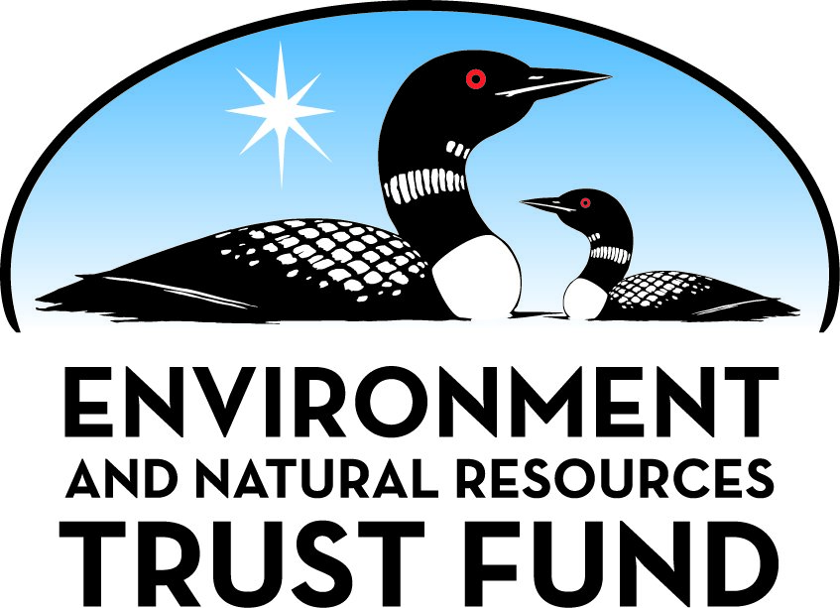

Environment and Natural Resources Trust Fund

M.L. 2025 Final Work Plan

General Information
ID Number: 2025-211
Staff Lead: Mike Campana
Date this document submitted to LCCMR: June 11, 2025
Project Title: Wastewater Chloride Reduction through Industrial Source Reduction Assistance
Project Budget: $247,000

Project Manager Information
Name: Kelsey Klucas
Organization: U of MN - School of Public Health
Office Telephone: (612) 624-4619
Email: kluc0035@umn.edu
Web Address: https://www.sph.umn.edu/

Project Reporting
Reporting Schedule: March 1 / September 1 of each year.
Project Completion: June 30, 2028
Final Report Due Date: August 14, 2028

Legal Information
Legal Citation: M.L. 2025, First Special Session, Chp. 1, Art. 2, Sec. 2, Subd. 04r
Appropriation Language: $247,000 the first year is from the trust fund to the Board of Regents of the University of Minnesota for the Minnesota Technical Assistance Program to provide technical assistance to businesses to cost-effectively reduce industrial and commercial chloride use in communities with high chloride effluent concentrations.
Appropriation End Date: June 30, 2028

Narrative
Project Summary: Project seeks to reduce chloride effluent in communities with high chloride concentrations by providing technical assistance to identify cost-effective ways to reduce industrial/commercial chloride use.
Describe the opportunity or problem your proposal seeks to address. Include any relevant background information.
Treatment facilities manage effluent as part of the public infrastructure needed for public health, economic development, and job growth. This project will provide source reduction technical assistance for industrial facilities discharging high chloride concentrations to their municipal wastewater facility or to surface water. Industries that generally use chloride in their processes include
• Food processing
• Rendering
• Leather tanning
• Brewing
• Ethanol production
• Metal fabrication
One teaspoon of salt pollutes five gallons of water. Chloride removal at wastewater treatment facilities is prohibitively expensive. Madison Metropolitan Sewerage District estimates capital costs for chloride removal for a plant with a capacity for 15 MGD range from $81 million to $193 million. By promoting strategies for chloride management at facilities that discharge to municipal wastewater systems or to surface water, the chloride entering Minnesota waters is reduced. The Minnesota Technical Assistance Program (MnTAP) has demonstrated source reduction strategies to reduce chloride use at industrial facilities while reducing costs.
• A vegetable pickling facility identified 460,500 lbs of annual salt reduction (279,000 lbs of chloride if NaCl) through process optimization.
• A meat processing facility identified 82,000 lbs of annual salt reduction (50,000 lbs of chloride) through water softener optimization.
What is your proposed solution to the problem or opportunity discussed above? Introduce us to the work you are seeking funding to do. You will be asked to expand on this proposed solution in Activities & Milestones.
Provide technical assistance to identify cost-effective ways to reduce industrial/commercial chloride use. MnTAP will identify target communities and industrial facilities with chloride challenges by analyzing state wastewater data and the Minnesota Pollution Control Agency’s impaired waters list. MnTAP will engage these communities and facilities by providing direct technical assistance to businesses and placing interns in businesses with high chloride reduction opportunity to launch conservation implementation.
What are the specific project outcomes as they relate to the public purpose of protection, conservation, preservation, and enhancement of the state’s natural resources?
10-20 communities and/or industrial facilities receive direct outreach for chloride source reduction technical assistance
5-10 industrial sites receive source reduction assessments
2-3 intern projects for chloride source reduction
At least 25,000 lbs annual chloride reduction
At least 2 success stories published
At least 2 presentations at sector specific events
1 webinar presented live and recorded for future viewing
1 webpage to share best management practices

Project Location
What is the best scale for describing where your work will take place?
Statewide
What is the best scale to describe the area impacted by your work?
Statewide
When will the work impact occur?
During the Project and In the Future

Activities and Milestones

Activity 1: Identify/Engage Locations with High Chloride Concentrations and Industrial Clients for Assistance Activities
Activity Budget: $33,000
Activity Description:
Select communities with wastewater facilities that would benefit from chloride source reduction technical assistance. This includes facilities with high chloride discharge levels that may be in areas with impaired surface water. Contact wastewater facilities, municipalities, and industrial facilities to share information on chloride reduction options and the potential impact on local surface water quality.
Activity Milestones:
Description | Approximate Completion Date
20-30 communities identified with high potential for effluent chloride reduction | March 31, 2026
10-20 communities and/or industrial facilities receive direct outreach for source reduction technical assistance | September 30, 2026
5-10 industrial sites agree to receive onsite source reduction assessments | March 31, 2027

Activity 2: Conduct Chloride Source Reduction Assessments at Industrial Facilities
Activity Budget: $185,000
Activity Description:
Conduct technical assistance assessments to identify and implement source reduction opportunities that will decrease wastewater chloride load. Technical assistance activities will recommend process optimization strategies and material substitution. Facilities with highly complex systems will be encouraged to apply to the MnTAP Intern Program for a summer intern to provide added engineering expertise to support identification, implementation, and outcome documentation of chloride reduction activities. An annual chloride reduction of 25,000 lbs prevents 15,000,000 gallons of water from being polluted with chloride.
Activity Milestones:
Description | Approximate Completion Date
5-10 onsite source reduction site assessments for chloride reduction | September 30, 2027
2-3 intern projects for chloride source reduction | September 30, 2027
All participating sites receive follow up assistance from MnTAP | June 30, 2028
At least 25,000 lbs annual chloride reduction | June 30, 2028

Activity 3: Share results and replication opportunity throughout the state
Activity Budget: $29,000
Activity Description:
Develop a process for conducting similar analysis through example case studies and lessons learned for broad dissemination to facilities across Minnesota for additional site engagement. Share information through publications, presentations, and webinars targeting wastewater facility staff, city managers, industries, and organizations that discharge high wastewater chloride load.
Activity Milestones:
Description | Approximate Completion Date
At least 2 success stories published | March 31, 2028
At least 2 presentations at sector specific events | June 30, 2028
1 webinar presented live and recorded for future viewing | June 30, 2028
1 webpage to share best management practices | June 30, 2028

Dissemination
Describe your plans for dissemination, presentation, documentation, or sharing of data, results, samples, physical collections, and other products and how they will follow ENRTF Acknowledgement Requirements and Guidelines.
General project information, general technical information, sign up mechanism to participate in the evaluation, publications and other project related information will be included in a series of web pages under the MnTAP Water pages http://www.mntap.umn.edu/focusareas/water/ as a new subpage dedicated to project activities. Periodic updates of project progress and publicly available results will be published in the MnTAP monthly electronic newsletter, Source, along with feature articles on the project web page. Access to these communication pieces will be through the current MnTAP publication web pages http://www.mntap.umn.edu/resources/publications/. All MnTAP resources are freely distributed for use in replicating and advancing the work.
Intern project information will be posted on the MnTAP Intern Program web pages for company solicitation, and student recruiting http://www.mntap.umn.edu/interns/. Intern project results will be posted under MnTAP Intern Past Projects http://www.mntap.umn.edu/interns/pastprojects/ and in the annual print and electronic intern project summary publication, Solutions http://www.mntap.umn.edu/resources/publications/solutions/.
Webinar materials that are presented as part of the project will be posted under MnTAP Resources and Tools on the MnTAP Webinars pages http://www.mntap.umn.edu/resources/webinars/ for future viewing and sharing.
The Minnesota Environment and Natural Resources Trust Fund (ENRTF) will be acknowledged through use of the trust fund logo or attribution language on project print and electronic media, publications, signage, and other communications per the ENRTF Acknowledgement Guidelines.

Long-Term Implementation and Funding
Describe how the results will be implemented and how any ongoing effort will be funded. If not already addressed as part of the project, how will findings, results, and products developed be implemented after project completion? If additional work is needed, how will this work be funded?
This project seeks to bring industrial/commercial technical assistance to communities and businesses throughout the state interested in chloride reduction strategies. Once developed and documented, these strategies will be available to communities, businesses, and existing programs that assist Minnesota communities with chloride reduction for replication beyond the program time period.

Other ENRTF Appropriations Awarded in the Last Six Years
Name | Appropriation | Amount Awarded
Wastewater Nutrient Reduction through Industrial Source Reduction Assistance | M.L. 2019, First Special Session, Chp. 4, Art. 2, Sec. 2, Subd. 04c | $200,000
Expanding Protection Of Minnesota Water Through Industrial Conservation | M.L. 2021, First Special Session, Chp. 6, Art. 5, Sec. 2, Subd. 04g | $178,000

Budget Summary
Category / Name | Subcategory or Type | Description | Purpose | Gen. Ineli gible | % Bene fits | # FTE | Class ified Staff? | $ Amount
Personnel
Senior Engineer |  | Technical assistance and training |  |  | 37.1% | 0.3 |  | $28,295
Engineer |  | Technical assistance and training |  |  | 33.5% | 1.65 |  | $139,036
Intern Manager |  | Hire, train, and supervise intern program |  |  | 33.5% | 0.15 |  | $17,177
Intern(s) |  | Execute site based projects |  |  | 7.7% | 0.7 |  | $30,695
Principal Investigator |  | Program administration, reporting |  |  | 37.1% | 0.15 |  | $27,297
 |  |  |  |  |  |  | Sub Total | $242,500
Contracts and Services
 |  |  |  |  |  |  | Sub Total | -
Equipment, Tools, and Supplies
 |  |  |  |  |  |  | Sub Total | -
Capital Expenditures
 |  |  |  |  |  |  | Sub Total | -
Acquisitions and Stewardship
 |  |  |  |  |  |  | Sub Total | -
Travel In Minnesota
 | Miles/ Meals/ Lodging | Mileage and per diem for travel within Minnesota to provide technical assistance | Provide on site visits to define water conservation opportunities. |  |  |  |  | $4,500
 |  |  |  |  |  |  | Sub Total | $4,500
Travel Outside Minnesota
 |  |  |  |  |  |  | Sub Total | -
Printing and Publication
 |  |  |  |  |  |  | Sub Total | -
Other Expenses
 |  |  |  |  |  |  | Sub Total | -
 |  |  |  |  |  |  | Grand Total | $247,000

Classified Staff or Generally Ineligible Expenses
Category/Name | Subcategory or Type | Description | Justification Ineligible Expense or Classified Staff Request

Non ENRTF Funds
Category | Specific Source | Use | Status | $ Amount
State
 |  |  | State Sub Total | -
Non-State
In-Kind | University of Minnesota Indirect rate 26% MTDC | Non-recovered indirect on grant total. | Secured | $64,220
 |  |  | Non State Sub Total | $64,220
 |  |  | Funds Total | $64,220

Total Project Cost: $311,220
This amount accurately reflects total project cost?
Yes

Attachments

Required Attachments

Visual Component
File:

Alternate Text for Visual Component
MPCA Chloride Conditions Map to demonstrate areas of MN impacted by high chloride. This map will serve to inform MnTAP efforts for outreach....

Supplemental Attachments

Capital Project Questionnaire, Budget Supplements, Support Letter, Photos, Media, Other
Title | File
MPCA Letter of Support
UMN Sponsored Projects Administration Authorization to Submit

Difference between Proposal and Work Plan

Describe changes from Proposal to Work Plan Stage
Updated dissemination information as requested.

Additional Acknowledgements and Conditions:
The following are acknowledgements and conditions beyond those already included in the above workplan:
Do you understand and acknowledge the ENRTF repayment requirements if the use of capital equipment changes?
N/A
Do you understand that travel expenses are only approved if they follow the "Commissioner's Plan" promulgated by the Commissioner of Management of Budget or, for University of Minnesota projects, the University of Minnesota plan?
Yes, I understand the UMN Policy on travel applies.
Does your project have potential for royalties, copyrights, patents, sale of products and assets, or revenue generation?
No
Do you understand and acknowledge IP and revenue-return and sharing requirements in 116P.10?
N/A
Do you wish to request reinvestment of any revenues into your project instead of returning revenue to the ENRTF?
N/A
Does your project include original, hypothesis-driven research?
No
Does the organization have a fiscal agent for this project?
No
Does your project include the pre-design, design, construction, or renovation of a building, trail, campground, or other fixed capital asset costing $10,000 or more or large-scale stream or wetland restoration?
No
Do you propose using an appropriation from the Environment and Natural Resources Trust Fund to conduct a project that provides children's services (as defined in Minnesota Statutes section 299C.61 Subd.7 as "the provision of care, treatment, education, training, instruction, or recreation to children")?
No
Provide the name(s) and organization(s) of additional individuals assisting in the completion of this project:
Laura Sevcik, University of Minnesota; Debb Grove, University of Minnesota
Do you understand that a named service contract does not constitute a funder-designated subrecipient or approval of a sole-source contract? In other words, a service contract entity is only approved if it has been selected according to the contracting rules identified in state law and policy for organizations that receive ENRTF funds through direct appropriations, or in the DNR’s reimbursement manual for non-state organizations. These rules may include competitive bidding and prevailing wage requirements
N/A

