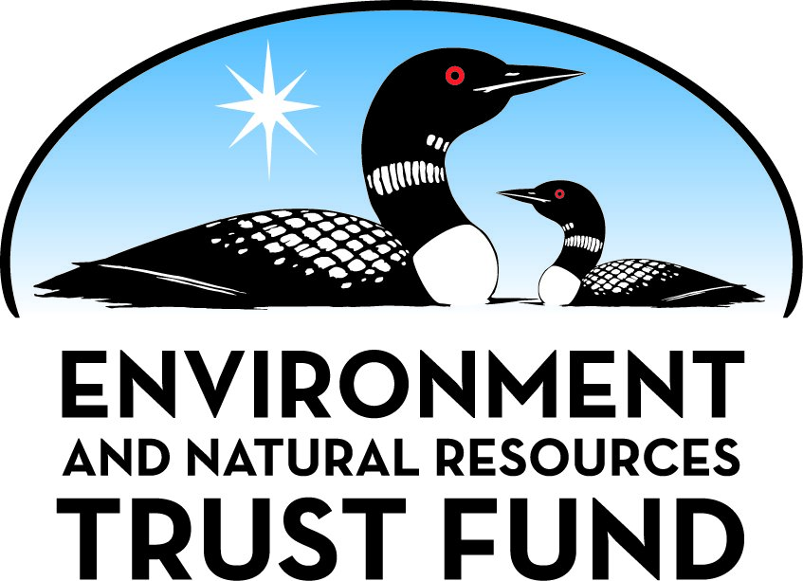

Environment and Natural Resources Trust Fund

M.L. 2025 Final Work Plan

General Information
ID Number: 2025-201
Staff Lead: Tiffany Schaufler
Date this document submitted to LCCMR: June 11, 2025
Project Title: Scandia Gateway Trail Connection: Recreation, Wetlands, Environmental Education
Project Budget: $907,000

Project Manager Information
Name: Kyle Morell
Organization: City of Scandia
Office Telephone: (651) 433-2274
Email: k.morell@ci.scandia.mn.us
Web Address: https://www.cityofscandia.com/

Project Reporting
Reporting Schedule: March 1 / September 1 of each year.
Project Completion: June 30, 2028
Final Report Due Date: August 14, 2028

Legal Information
Legal Citation: M.L. 2025, First Special Session, Chp. 1, Art. 2, Sec. 2, Subd. 09h
Appropriation Language: $907,000 the first year is from the trust fund to the commissioner of natural resources for an agreement with the city of Scandia to engineer, design, and construct a bike and pedestrian trail to connect recreational, cultural, and environmental resources in Scandia to the state Gateway Trail. This appropriation is also to create and install educational interpretive signage about wetlands and rain gardens near the trail.
Appropriation End Date: June 30, 2028

Narrative
Project Summary: Bike/pedestrian connection via a wetland trail connecting the state Gateway Trail to recreational/cultural/environmental resources in Scandia -- Gammelgården Museum, playgrounds, athletic facilities, amphitheater, splash pad, and
Describe the opportunity or problem your proposal seeks to address. Include any relevant background information.
Scandia is located at the north terminus of the Gateway Trail, which will pass through William O’Brien State Park before landing at a trailhead in the Scandia Village Center. In close proximity to the trailhead, Scandia offers multiple current and under-development resources to greatly enhance Trail users' environmental education and recreation experiences. The project opportunity is to make these resources far more accessible and integrated for users while simultaneously providing access to natural resources and education about the value of wetlands and rain gardens.
What is your proposed solution to the problem or opportunity discussed above? Introduce us to the work you are seeking funding to do. You will be asked to expand on this proposed solution in Activities & Milestones.
This proposal will create a destination and trail network between the Gateway Trails terminus and multiple Scandia facilities. A new bike/pedestrian trail around and across the Community Center wetland will connect recreational amenities at the Scandia Community Center, the future Water Tower Barn Scandia (Water Tower Barn) arts and heritage center, and the Gammelgården Museum. This new trail and Gateway connection will greatly enhance outdoor recreational options for trail users and those visiting William O’Brien State Park by providing access to the following amenities.
• Gammelgården Museum, internationally known for preserving Swedish pioneer buildings;
• Scandia’s playgrounds, recently upgraded, along with tennis courts, baseball and t-ball fields, and ice-skating rinks;
• Water Tower Barn, including a new Museum/ /Cultural center, a splash pad, and the only large-scale amphitheater in the St. Croix Valley. Water Tower Barn programming will focus on water quality, wetland protection, and the historical interpretation of early windmill engineering for public water distribution.
The LCCMR request includes interpretive signage about the wetlands and rain gardens. This signage will complement the water engineering, water quality, and education components of the Water Tower Barn project, enhancing the water-oriented environmental programming proposed for Scandia Elementary School.
What are the specific project outcomes as they relate to the public purpose of protection, conservation, preservation, and enhancement of the state’s natural resources?
The project will construct a wetland boardwalk across the publicly owned wetland, which is the centerpiece of the Community Center Commons. The boardwalk will feature interpretive signage about the wetlands and rain gardens, promoting environmental education and wetland conservation. The boardwalk will connect to a 2,850-foot pedestrian and bicycle trail that surrounds the wetland and extends across the boardwalk, creating two safe road crossings for access from the Gateway Trail to the Community Center Commons and from the Commons to the Gammelgården Museum.

Project Location
What is the best scale for describing where your work will take place?
Region(s): Metro
What is the best scale to describe the area impacted by your work?
Region(s): Metro
When will the work impact occur?
In the Future

Activities and Milestones

Activity 1: Completion of Design Process
Activity Budget: $72,000
Activity Description:
A consulting engineer has completed the preliminary design of the wetland trail system. This design was developed based on a 2022 field survey of the site, and a wetland delineation was completed in 2020. The field survey selected the best locations on the site for wetland observation. The City Council reviewed and approved the preliminary plans at their December 2023 meeting before submitting the grant request. The City's engineer will finalize the design and obtain the necessary permitting from the local watershed district. No Department of Administration pre-design review is required for this project.
Activity Milestones:
Description | Approximate Completion Date
Wetland Delineation | May 31, 2020
Preliminary Site Survey | May 31, 2022
Completion of any application topographical and survey work | July 31, 2025
Authorization of Design and Specifications | July 31, 2025
Approval of Design and Specifications | December 31, 2025

Activity 2: Bidding and Construction
Activity Budget: $835,000
Activity Description:
The City engineer, Bolton and Menk, will design the wetland trail system. It will consist of 2,850 feet of trail on City property, 390 feet of wetland boardwalk, and 500 feet of new sidewalk along County Road 3 in Scandia. The wetland trail system will feature interpretive signage highlighting the value of wetlands and rain gardens in filtering stormwater, thereby acting as natural water purifiers to maintain healthy aquatic ecosystems downstream. The Scandia Heritage Alliance, a local partner on the trail project, will offer water-focused environmental day camps for kids, elementary school field trips, and rain garden workshops for adults. The wetland boardwalk will allow kids and adults to get up close to the wetland, and for kids to gather water for scientific experiments. Once final engineering is completed, construction services will be acquired through the City’s contract and bidding services. The project will be bid out over the winter of 2025/2026. Construction is scheduled to begin in the spring of 2026 and is expected to be completed the same year. Funding for the project will be acquired through the LCCMR grant award and local contributions.
Activity Milestones:
Description | Approximate Completion Date
Authorize Preparation of Bids for Construction | January 31, 2026
Approve Bids and Award Project | March 31, 2026
Complete Construction of Wetland Trails and Interpretive Signs | December 31, 2026
Notice of Funding Restriction Recorded | December 31, 2026
Certificate of Occupancy | December 31, 2026
Signage Installed with ENRFT Language or Logo | December 31, 2026
Open for Intended Use | December 31, 2026

Project Partners and Collaborators
Name | Organization | Role | Receiving Funds
Susan Rodsjo | Scandia Heritage Alliance | Scandia Heritage Alliance Board Chair and Marketing Communications Manager | No
Ryan Goodman | Bolton & Menk | Scandia City Engineer | No
Peter Hilger | University of Minnesota | Consulting architect on the Scandia Heritage Alliance Water Tower Barn Arts and Heritage Center | No
Adam Thiele | Anderson Consulting | Consulting engineer on the wetland trail project | Yes
John Hermna | Scandia Heritage Alliance | Scandia Heritage Alliance Board member, retired real estate attorney, and former LCCMR citizen board member | No
Greg Amundson | Scandia Heritage Alliance | Scandia Heritage Alliance Board member and SHA construction manager | No
Ann Rinkenberger | Gammelgården Museum | Executive Director of Gammelgården Museum | No

Dissemination
Describe your plans for dissemination, presentation, documentation, or sharing of data, results, samples, physical collections, and other products and how they will follow ENRTF Acknowledgement Requirements and Guidelines.
Acknowledgment of ENRTF's project funding will be denoted on signage along the trail system. The City of Scandia will also prepare a press release for the newspaper, city website, City Facebook page, and Next Door account, recognizing ENRTF's significant role in making this project possible. This notice will be done following ENRTF Acknowledgement Guidelines. Our Fall newsletter includes full acknowledgment to ENRTF and LCCMR. The press release will also attempt to include additional optional language and the fund logo.

Long-Term Implementation and Funding
Describe how the results will be implemented and how any ongoing effort will be funded. If not already addressed as part of the project, how will findings, results, and products developed be implemented after project completion? If additional work is needed, how will this work be funded?
This project will result in the construction of a wetland trail system connecting Scandia’s Gateway Trail terminus to recreational, cultural, and environmental educational resources in the Scandia City Center. No results, findings or other unanswered questions are anticipated to result from this project. Additional construction of future trail segments may be obtained through state appropriation and/or other grant opportunities available to the City of Scandia. The short-term goal, which is encompassed in this project, is to connect the Gateway Trail to the Scandia City Center and its various amenities.

Other ENRTF Appropriations Awarded in the Last Six Years
Name | Appropriation | Amount Awarded
Scandia Gateway Trail to William O'Brien State Park | M.L. 2023, , Chp. 60, Art. 2, Sec. 2, Subd. 09g | $2,689,000

Budget Summary
Category / Name | Subcategory or Type | Description | Purpose | Gen. Ineli gible | % Bene fits | # FTE | Class ified Staff? | $ Amount
Personnel
 |  |  |  |  |  |  | Sub Total | -
Contracts and Services
Project Engineer and Consulting Architect | Service Contract | The Consultant will complete the final design, engineering, and specifications for the project and carry out project administration responsibilities under the supervision of the City |  |  |  | 1.5 |  | $72,000
TBD | Service Contract | Construction of Wetland Trails |  |  |  | 10 |  | $835,000
 |  |  |  |  |  |  | Sub Total | $907,000
Equipment, Tools, and Supplies
 |  |  |  |  |  |  | Sub Total | -
Capital Expenditures
 |  |  |  |  |  |  | Sub Total | -
Acquisitions and Stewardship
 |  |  |  |  |  |  | Sub Total | -
Travel In Minnesota
 |  |  |  |  |  |  | Sub Total | -
Travel Outside Minnesota
 |  |  |  |  |  |  | Sub Total | -
Printing and Publication
 |  |  |  |  |  |  | Sub Total | -
Other Expenses
 |  |  |  |  |  |  | Sub Total | -
 |  |  |  |  |  |  | Grand Total | $907,000

Classified Staff or Generally Ineligible Expenses
Category/Name | Subcategory or Type | Description | Justification Ineligible Expense or Classified Staff Request

Non ENRTF Funds
Category | Specific Source | Use | Status | $ Amount
State
 |  |  | State Sub Total | -
Non-State
Cash | Scandia Heritage Alliance | Pre-Design of Wetland Trail System | Secured | $10,680
Cash | Scandia Heritage Alliance | Designs of a wetland overlook and walkway through the Water Tower Barn property | Secured | $78,000
Cash | City of Scandia | Design and construction contribution | Secured | $266,000
 |  |  | Non State Sub Total | $354,680
 |  |  | Funds Total | $354,680

Total Project Cost: $1,261,680
This amount accurately reflects total project cost?
Yes

Attachments

Required Attachments

Visual Component
File:

Alternate Text for Visual Component
The Visual Component maps the wetland trail system on the Water Tower Barn and Community Center properties. As well as an overhead picture of the project location in Scandia...

Financial Capacity
Title | File
2022 Audited Financial Statements

Board Resolution or Letter
Title | File
Authorizing Resolution

Supplemental Attachments

Capital Project Questionnaire, Budget Supplements, Support Letter, Photos, Media, Other
Title | File
Capital Construction Project Questionnaire
Scandia Elementary School Letter of Support
Budget Addendum_Received post-close
Page 4 Capital Construction Project Checklist
Updated Capital Construction Project Questionnaire

Difference between Proposal and Work Plan

Describe changes from Proposal to Work Plan Stage
Changes to the project's budget were made to reflect the funding amount awarded to the project.

Additional Acknowledgements and Conditions:
The following are acknowledgements and conditions beyond those already included in the above workplan:
Do you understand and acknowledge the ENRTF repayment requirements if the use of capital equipment changes?
N/A
Do you understand that travel expenses are only approved if they follow the "Commissioner's Plan" promulgated by the Commissioner of Management of Budget or, for University of Minnesota projects, the University of Minnesota plan?
N/A
Does your project have potential for royalties, copyrights, patents, sale of products and assets, or revenue generation?
No
Do you understand and acknowledge IP and revenue-return and sharing requirements in 116P.10?
N/A
Do you wish to request reinvestment of any revenues into your project instead of returning revenue to the ENRTF?
N/A
Does your project include original, hypothesis-driven research?
No
Does the organization have a fiscal agent for this project?
No
Does your project include the pre-design, design, construction, or renovation of a building, trail, campground, or other fixed capital asset costing $10,000 or more or large-scale stream or wetland restoration?
Yes
Do you propose using an appropriation from the Environment and Natural Resources Trust Fund to conduct a project that provides children's services (as defined in Minnesota Statutes section 299C.61 Subd.7 as "the provision of care, treatment, education, training, instruction, or recreation to children")?
No
Provide the name(s) and organization(s) of additional individuals assisting in the completion of this project:
John Herman, Scandia Heritage Alliance
Do you understand that a named service contract does not constitute a funder-designated subrecipient or approval of a sole-source contract? In other words, a service contract entity is only approved if it has been selected according to the contracting rules identified in state law and policy for organizations that receive ENRTF funds through direct appropriations, or in the DNR’s reimbursement manual for non-state organizations. These rules may include competitive bidding and prevailing wage requirements
Yes, I understand

