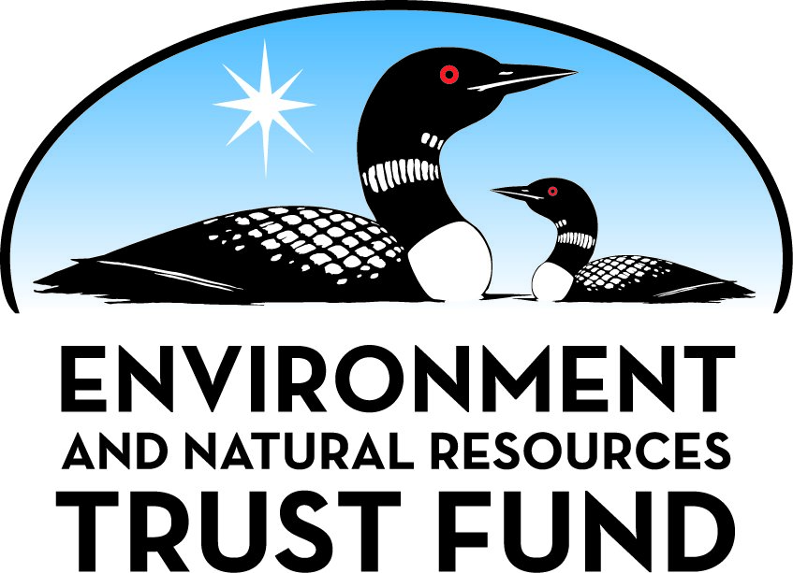

Environment and Natural Resources Trust Fund

M.L. 2025 Final Work Plan

General Information
ID Number: 2025-188
Staff Lead: Michael Varien
Date this document submitted to LCCMR: June 9, 2025
Project Title: Health and Disease Monitoring in Minnesota Wildlife
Project Budget: $750,000

Project Manager Information
Name: Arno Wuenschmann
Organization: U of MN - Minnesota Veterinary Diagnostic Laboratory
Office Telephone: (612) 624-3249
Email: wunsc001@umn.edu
Web Address: vdl.umn.edu

Project Reporting
Reporting Schedule: March 1 / September 1 of each year.
Project Completion: June 30, 2028
Final Report Due Date: August 14, 2028

Legal Information
Legal Citation: M.L. 2025, First Special Session, Chp. 1, Art. 2, Sec. 2, Subd. 03s
Appropriation Language: $750,000 the first year is from the trust fund to the Board of Regents of the University of Minnesota, Minnesota Veterinary Diagnostic Laboratory, to collaborate with wildlife rehabilitation organizations and other wildlife health professionals throughout Minnesota to enhance the state's health and disease surveillance, preparedness, and response efforts.
Appropriation End Date: June 30, 2028

Narrative
Project Summary: The project will enhance a. knowledge of wildlife health and disease and b. diagnostic capacity by significantly increasing the number of postmortem examinations of free-ranging animals and training wildlife pathologists.
Describe the opportunity or problem your proposal seeks to address. Include any relevant background information.
Wildlife holds cultural, historical, and ecological significance, enriching the lives of Minnesotans through recreational activities, sustenance hunting, and every day enjoyment. The state's wildlife faces persistent threats from endemic and emerging diseases, such as white nose syndrome, which can lead to significant mortality events. Protecting wildlife health is vital for species conservation but also for safeguarding human and livestock health. Diseases like rabies and tularemia as well as certain parasites pose risks to both wildlife and humans. Emergence of new pathogens, such as SARS-COV-2, requires vigilance to determine whether cross-over to new host populations is occurring. Timely and thorough examination of deceased wildlife by trained pathologists is essential for disease monitoring and mitigation efforts. Nevertheless, funding for wildlife health monitoring remains limited. This project aims to address this challenge by leveraging various sources, including carcasses brought to the Minnesota Veterinary Diagnostic Laboratory from the Wildlife Rehabilitation Center, field biologists, and other wildlife rehabilitators across the state, and those collected through the Bell Museum's carcass collection grant (LCCMR grant 2023-146). By maximizing access to suitable wildlife specimens, we enhance disease surveillance and improve our understanding of disease dynamics across Minnesota, while protecting human, animal, and ecosystem health.
What is your proposed solution to the problem or opportunity discussed above? Introduce us to the work you are seeking funding to do. You will be asked to expand on this proposed solution in Activities & Milestones.
We are seeking funding to enhance wildlife health and disease monitoring of free-ranging animals at the Minnesota Veterinary Diagnostic Laboratory over a three-year period. Specifically, our project aims to cover the fees for complete postmortem examinations of sick or dead wildlife reported by the public or e.g. field biologists of tribal nations for determination of the cause(s) of their illness or death. Additionally, we propose to expand the scope of postmortem examinations to include animals that perish under the care of licensed wildlife rehabilitators and veterinarians at wildlife rehabilitation organizations throughout the state of Minnesota, such as the Wildlife Rehabilitation Center (WRC). Currently, limited funding impedes postmortem examination of wildlife mortality cases at these facilities because all resources are focused on live animals resulting in loss of valuable information.
Furthermore, our funding request includes support for veterinary pathology residents for three years. This investment will enable three pathology residents to specialize in the diseases affecting wildlife, bolstering expertise in this critical but underserved field. By subsidizing postmortem examinations and investing in specialized training, our project aims to improve wildlife disease surveillance, enhance understanding of wildlife health dynamics, and contribute to the overall well-being of Minnesota's ecosystems.
What are the specific project outcomes as they relate to the public purpose of protection, conservation, preservation, and enhancement of the state’s natural resources?
The outcomes of this project directly advance the protection, conservation, and enhancement of Minnesota’s natural resources via the following outcomes:
1. Early detection of emerging infectious and possibly zoonotic diseases.
2. Informed wildlife management decisions based on comprehensive disease surveillance data.
3. Enhanced care for wildlife in rehabilitation centers, ultimately leading toward better release rates.
4. Establishment of a robust disease surveillance system aligned with the One Health model, enhancing statewide preparedness and response efforts.
5. Provision of specialized training in wildlife pathology.
These outcomes represent a critical step towards safeguarding Minnesota's wildlife populations and ecosystems for future generations.

Project Location
What is the best scale for describing where your work will take place?
Statewide
What is the best scale to describe the area impacted by your work?
Statewide
When will the work impact occur?
During the Project and In the Future

Activities and Milestones

Activity 1: Performing postmortem examination of free-ranging animals that are found dead or that died while under care by wildlife rehabilitators
Activity Budget: $750,000
Activity Description:
The funding enables postmortem examinations of vertebrate wildlife species, including amphibians, reptiles, birds, and mammals, submitted to the Minnesota Veterinary Diagnostic Laboratory throughout the study period. These examinations will entail a gross inspection of the carcasses and the microscopic examination of a wide variety of organs. Specialized investigative methods, such as microbiology, toxicology, electron microscopy and molecular diagnostics will be employed at the discretion of the submitting clinicians and pathologists. This holistic approach ensures that potential diseases or health issues affecting a wide range of wildlife species are identified and characterized accurately. Results will be communicated in real time to the submitters and the data will be analyzed as a whole.
The submitted animals enable the training of residents in wildlife pathology but also veterinary students and veterinary clinicians working with wildlife. By examining a diverse array of species, we can gain valuable insights into disease dynamics, health trends, and potential threats to wildlife, livestock and human health. This activity will not only enhance our understanding of wildlife health but also contribute to the development of effective management strategies and interventions to protect Minnesota's precious natural resources for the benefit of hunters, non-consumptive resource users, and future.
Activity Milestones:
Description | Approximate Completion Date
Complete postmortem examination of 400 wildlife cases (July 2025 to June 2026) | June 30, 2026
Complete postmortem examination of 400 wildlife cases (July 2026 to June 2027) | June 30, 2027
Complete postmortem examination of 400 wildlife cases (July 2027 to June 2028)(final) | June 30, 2028
Share raw data and Summarize, analyze and report data quarterly to public (on VDL webpage) | June 30, 2028

Project Partners and Collaborators
Name | Organization | Role | Receiving Funds
Renee Schott | Wildlife Rehabilitation Center of Minnesota | Triage cases for submission to Diagnostic Laboratory, analyze data, report results to public | Yes
Dr. Michelle Carstensen | Minnesota Department of Natural Resources | Triaging cases, submitting cases; analyzing data, public relations | No

Dissemination
Describe your plans for dissemination, presentation, documentation, or sharing of data, results, samples, physical collections, and other products and how they will follow ENRTF Acknowledgement Requirements and Guidelines.
1) The submitter/submitting agency of any given case will receive the necropsy results via email in a timely manner (just as any client of the Minnesota VDL does).
2) - If reportable diseases were diagnosed: The Department of Natural Resources and Board of Animal Health will receive results and will report the results to the target audiences and public as regulated by law.
- In cases in which non-reportable diseases were diagnosed:
(a) We will create an email distribution list with regular email updates of summaries to the target audiences (Department of Natural Resources, Wildlife Center of Minnesota, the broader wildlife rehabilitation community of Minnesota and the field biology departments of Minnesota's tribal nations); summaries will contain the animal species, sex, estimated age class, location (county level - to the extend that no specific farms or households can be identified), and final diagnosis; the Minnesota VDL has capabilities and proven records of extracting and reporting data and creating email lists and performing email updates.
b) We will post regularly summaries (e.g. every 3 months) on the Minnesota VDL website that is accessible to the public.
c) We will create a "Wildlife Case of the Month" tab on the Minnesota VDL webpage that is accessible to the public.
d) The submitted cases are being used to teach veterinary students and wildlife health professionals on the topic of "Wildlife Diseases".
e) Furthermore, we are in the process of exploring the option of having an outreach activity at the MN State Fair in the DNR building or the University of Minnesota building.
3) ENRTF will be acknowledged according to the guidelines (e.g. by using the ENRTF logo and attribution language) for any study-related communications and outreach.

Long-Term Implementation and Funding
Describe how the results will be implemented and how any ongoing effort will be funded. If not already addressed as part of the project, how will findings, results, and products developed be implemented after project completion? If additional work is needed, how will this work be funded?
This project will identify existing and novel disease threats to Minnesota wildlife and by extension, livestock and Minnesotans. Disease surveillance ideally is a long-term effort in order to map spatial and temporal trends. In this sense, the project will provide baseline data that data of future projects can be compared to. Specific findings of the proposed project period will lead to scientific discoveries that in turn will generate spin off projects. Furthermore, the findings have the potential to improve patient care and hereby treatment outcomes for wildlife at the Wildlife Rehabilitation Center and other rehabilitation organizations in the state.

Budget Summary
Category / Name | Subcategory or Type | Description | Purpose | Gen. Ineli gible | % Bene fits | # FTE | Class ified Staff? | $ Amount
Personnel
PI, pathologist |  | Conduct postmortem examinations, report, summarize and analyze data, project oversight |  |  | 37.1% | 0.6 |  | $164,062
Pathology Resident |  | Conduct postmortem examinations; summarize, analyze and report data quarterly |  |  | 7.7% | 2.4 |  | $132,111
Laboratory technician |  | Assist with postmortem examinations, organize data and images |  |  | 33.5% | 1.02 |  | $83,332
 |  |  |  |  |  |  | Sub Total | $379,505
Contracts and Services
Wildlife Rehabilitation Center of Minnesota | Subaward | WRC triages cases; submitting cases for postmortem examinations with relevant information (including date, location, signalment, clinical history), assist in analyzing data. About $28.434 are for labor involved with the submission of cases for necropsy, $17,160 are for courier service to the VDL and $915 are for disposables. |  |  |  | 0.03 |  | $46,509
Minnesota Veterinary Diagnostic Laboratory | Internal services or fees (uncommon) | These are the fees for the postmortem examination of 1200 wild animals by the pathologists at the VDL ($182/animal) and include the gross examination, microscopic examination and microbiologic examination (bacteriology). |  |  |  | - |  | $218,094
Minnesota Veterinary Diagnostic Laboratory | Internal services or fees (uncommon) | Some of the cases will require more advanced testing (including toxicology, electron microscopy and molecular diagnostics) as determined by the submitting clinicians and the pathologists. These fees are charged in addition to the regular necropsy fees. |  |  |  | - |  | $105,892
 |  |  |  |  |  |  | Sub Total | $370,495
Equipment, Tools, and Supplies
 |  |  |  |  |  |  | Sub Total | -
Capital Expenditures
 |  |  |  |  |  |  | Sub Total | -
Acquisitions and Stewardship
 |  |  |  |  |  |  | Sub Total | -
Travel In Minnesota
 |  |  |  |  |  |  | Sub Total | -
Travel Outside Minnesota
 |  |  |  |  |  |  | Sub Total | -
Printing and Publication
 |  |  |  |  |  |  | Sub Total | -
Other Expenses
 |  |  |  |  |  |  | Sub Total | -
 |  |  |  |  |  |  | Grand Total | $750,000

Classified Staff or Generally Ineligible Expenses
Category/Name | Subcategory or Type | Description | Justification Ineligible Expense or Classified Staff Request

Non ENRTF Funds
Category | Specific Source | Use | Status | $ Amount
State
In-Kind | Minnesota Veterinary Diagnostic Laboratory | 0.3 FTE of PI | Secured | $246,093
In-Kind | Department of Natural Resources | 100 hours of Dr. Michelle Carstensen | Secured | $16,200
In-Kind | Minnesota veterinary Diagnostic Laboratory | 0.16 FTE of a laboratory technician | Secured | $40,329
 |  |  | State Sub Total | $302,622
Non-State
 |  |  | Non State Sub Total | -
 |  |  | Funds Total | $302,622

Total Project Cost: $1,052,622
This amount accurately reflects total project cost?
Yes

Attachments

Required Attachments

Visual Component
File:

Alternate Text for Visual Component
Citizens collaborate with MN DNR and wildlife rehabilitators to help diseased animals and investigate mortality events. The investigation of the animals by pathologists is a highly efficient method of surveilling wildlife populations. The grant aims at providing funding to increase postmortem examinations of wildlife and training of wildlife pathologists....

Supplemental Attachments

Capital Project Questionnaire, Budget Supplements, Support Letter, Photos, Media, Other
Title | File
DNR support letter
VDL Support letter
Bell Museum Support Letter
Dr. Wolf Support Letter
Secretary of State Good Standing
Tax exemption letter
UMN 2023 Audit
Board Reviewed Financial Statement
U of MN approval letter

Difference between Proposal and Work Plan

Describe changes from Proposal to Work Plan Stage
We addressed the 7 provided comments in this revised submission.

Additional Acknowledgements and Conditions:
The following are acknowledgements and conditions beyond those already included in the above workplan:
Do you understand and acknowledge the ENRTF repayment requirements if the use of capital equipment changes?
N/A
Do you understand that travel expenses are only approved if they follow the "Commissioner's Plan" promulgated by the Commissioner of Management of Budget or, for University of Minnesota projects, the University of Minnesota plan?
N/A
Does your project have potential for royalties, copyrights, patents, sale of products and assets, or revenue generation?
No
Do you understand and acknowledge IP and revenue-return and sharing requirements in 116P.10?
N/A
Do you wish to request reinvestment of any revenues into your project instead of returning revenue to the ENRTF?
N/A
Does your project include original, hypothesis-driven research?
No
Does the organization have a fiscal agent for this project?
No
Does your project include the pre-design, design, construction, or renovation of a building, trail, campground, or other fixed capital asset costing $10,000 or more or large-scale stream or wetland restoration?
No
Do you propose using an appropriation from the Environment and Natural Resources Trust Fund to conduct a project that provides children's services (as defined in Minnesota Statutes section 299C.61 Subd.7 as "the provision of care, treatment, education, training, instruction, or recreation to children")?
No
Provide the name(s) and organization(s) of additional individuals assisting in the completion of this project:
University of Minnesota - Brett Carlson
Do you understand that a named service contract does not constitute a funder-designated subrecipient or approval of a sole-source contract? In other words, a service contract entity is only approved if it has been selected according to the contracting rules identified in state law and policy for organizations that receive ENRTF funds through direct appropriations, or in the DNR’s reimbursement manual for non-state organizations. These rules may include competitive bidding and prevailing wage requirements
N/A

