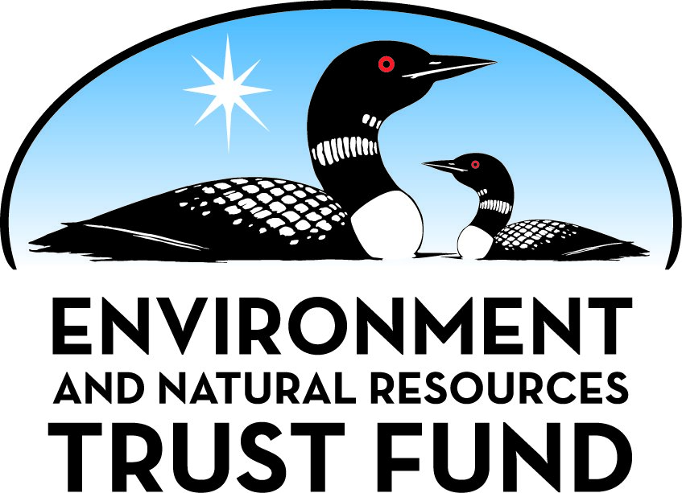

Environment and Natural Resources Trust Fund

M.L. 2025 Final Work Plan

General Information
ID Number: 2025-173
Staff Lead: Michael Varien
Date this document submitted to LCCMR: June 12, 2025
Project Title: Boardwalk Over Boggy Land for Recreational Purposes
Project Budget: $148,000

Project Manager Information
Name: Val Martin
Organization: City of Battle Lake
Office Telephone: (218) 864-0424
Email: cityclerk@battlelakemn.org
Web Address: https://battlelakemn.org/

Project Reporting
Reporting Schedule: March 1 / September 1 of each year.
Project Completion: June 30, 2028
Final Report Due Date: August 14, 2028

Legal Information
Legal Citation: M.L. 2025, First Special Session, Chp. 1, Art. 2, Sec. 2, Subd. 09e
Appropriation Language: $148,000 the first year is from the trust fund to the commissioner of natural resources for an agreement with the city of Battle Lake to design and construct a boardwalk over city land to protect wetlands and to increase community access to natural areas and wildlife habitat.
Appropriation End Date: June 30, 2028

Narrative
Project Summary: Construct a 400-ft long, 5-ft wide boardwalk over undevelopable city land giving walkers and hikers access to a boggy wildlife habitat while maintaining drainage considerations for low areas
Describe the opportunity or problem your proposal seeks to address. Include any relevant background information.
The City of Battle Lake wants to turn undevelopable city property into a recreational asset that people of all ages can enjoy. The property is comprised of high ground as well as wet, boggy land that collects rain and snow as well as stormwater. The low-lying area, with some enhancements, gives the city an opportunity to showcase a natural wetland habitat with its various flora and fauna. While creating a recreational asset, the city can ameliorate drainage challenges caused by ever-changing environmental conditions that dry/wet years and seasons raise. When completed, this project will provide learning opportunities for public school students as well childcare center which is located along the proposed trail.
What is your proposed solution to the problem or opportunity discussed above? Introduce us to the work you are seeking funding to do. You will be asked to expand on this proposed solution in Activities & Milestones.
Funding allows the construction of a 400-ft long, 5-ft wide boardwalk over the low-lying portion of city-owned property as part of enhancing a natural habitat on otherwise undevelopable land. By constructing a boardwalk over a boggy area of the property, we give community members and visitors an opportunity to experience a wetland habitat while protecting the land as a stormwater drainage area. The introduction of native plantings conducive to wet environments will not only provide a visual enhancement to the natural environment but will assist the city’s goal of maximizing the use of drainage facilities as part of managing today’s changing environment. With LCCMR small-project funding, the City of Battle Lake can quickly and efficiently implement plans to add a bog-walk trail conducive to recreational, ecological, and native habitat purposes. As the boardwalk will eventually connect to a local park and larger trail system, it expands outdoor recreational opportunities within the area along with connecting residential and commercial properties.
What are the specific project outcomes as they relate to the public purpose of protection, conservation, preservation, and enhancement of the state’s natural resources?
The boardwalk increases public access for recreation in that it opens an otherwise inaccessible property to walkers and hikers, for children and adults. It is of ecological value in that its interpretive signage identifies the flora and fauna that exist in the wetlands and describes the symbiotic relationships that exist, thus serving an educational function. It serves a preservation purpose in that it protects a boggy area and its habitat. It enhances natural resources in that it links to a local park and eventually a city trail system.

Project Location
What is the best scale for describing where your work will take place?
City(s): Battle Lake
What is the best scale to describe the area impacted by your work?
County(s): Otter Tail
When will the work impact occur?
During the Project

Activities and Milestones

Activity 1: Funding Procurement
Activity Budget: $1,875
Activity Description:
The first step will be funding procurement for the proposed project, with the property already owned by the City, and a 25% match committed by the City Council, funding for the remaining portions of the project will dictate the scope and proposed improvements. Funding is being pursued primarily through the LCCMR process, with local funding for additional trail components outside of the scope of this application.
Activity Milestones:
Description | Approximate Completion Date
Review funding alternatives and awards. | July 31, 2024

Activity 2: Boardwalk Design and Preconstruction Investigation
Activity Budget: $17,125
Activity Description:
The proposed design and preconstruction investigation would be completed by the City's Engineer, and assisted by various Geotechnical and Structural Design team members. The design will finalize the alignment and location of the proposed boardwalk along with investigating the underlying materials for verification of the structure needed to support the proposed improvements.
Activity Milestones:
Description | Approximate Completion Date
Environmental Site Assessment | August 31, 2025
Site Survey | August 31, 2025
SHPO Consultation | September 30, 2025
Dept of Admin Pre-Design Review | December 31, 2025
Design completion, bidding or project procurement | April 30, 2026

Activity 3: Boardwalk Bidding and Construction
Activity Budget: $129,000
Activity Description:
Following the completion of the design, the project will be publicly bid in accordance with Minnesota Statutes and awarded to the lowest responsible bidder. After award, the winning bidder will complete contracts to complete the tasks, and construction of the proposed boardwalk will commence. The proposed construction will be completed within the timeframes associated with this application, with completion by the end of 2026 allowing for access for the public to the proposed improvements following the construction completion.
Activity Milestones:
Description | Approximate Completion Date
Verify Funds Secured | August 31, 2025
Project Bidding | May 31, 2026
Construction | September 30, 2026
Installed ENRTF Logo Signage | September 30, 2026
Notice of Funding Restrictions Recorded | October 31, 2026
Certificate of Occupancy or Equivalent Obtained | October 31, 2026
Open for intended Use | October 31, 2026

Dissemination
Describe your plans for dissemination, presentation, documentation, or sharing of data, results, samples, physical collections, and other products and how they will follow ENRTF Acknowledgement Requirements and Guidelines.
Due to the nature of the proposed project including the construction of facilities to be used for accessibility over natural resources, the dissemination of the project will be primarily focused on the acknowledgement of the funding utilized to construct the facility at the entrance to the proposed boardwalk. In addition to the acknowledgement, education components at other locations along the trail system will further outline the use and need for the various components of the environment surrounding the facilities and how they are used not only for wildlife use, but for systems that have evolved to address the changing climate, including varying precipitation, water use and supply, and treatment.

Long-Term Implementation and Funding
Describe how the results will be implemented and how any ongoing effort will be funded. If not already addressed as part of the project, how will findings, results, and products developed be implemented after project completion? If additional work is needed, how will this work be funded?
Construction of the boardwalk could begin as soon as funding is in place. Along with the boardwalk, there will be native planting conducive to the wetland habitat. This will start after the boardwalk is completed and will be overseen by a professional. Ongoing maintenance will become part of the City of Battle Lake's Capital Improvement plan and the City will be dedicated to keeping the structure in good condition and will also repair and maintain and needed.

Budget Summary
Category / Name | Subcategory or Type | Description | Purpose | Gen. Ineli gible | % Bene fits | # FTE | Class ified Staff? | $ Amount
Personnel
 |  |  |  |  |  |  | Sub Total | -
Contracts and Services
Engineering | Service Contract | Engineering Design and Construction Administration |  |  |  | 0.1 |  | $25,000
Service Contract | Subaward | Construction of the proposed boardwalk and subsequent connections to the trail system. |  |  |  | 1 |  | $123,000
 |  |  |  |  |  |  | Sub Total | $148,000
Equipment, Tools, and Supplies
 |  |  |  |  |  |  | Sub Total | -
Capital Expenditures
 |  |  |  |  |  |  | Sub Total | -
Acquisitions and Stewardship
 |  |  |  |  |  |  | Sub Total | -
Travel In Minnesota
 |  |  |  |  |  |  | Sub Total | -
Travel Outside Minnesota
 |  |  |  |  |  |  | Sub Total | -
Printing and Publication
 |  |  |  |  |  |  | Sub Total | -
Other Expenses
 |  |  |  |  |  |  | Sub Total | -
 |  |  |  |  |  |  | Grand Total | $148,000

Classified Staff or Generally Ineligible Expenses
Category/Name | Subcategory or Type | Description | Justification Ineligible Expense or Classified Staff Request

Non ENRTF Funds
Category | Specific Source | Use | Status | $ Amount
State
 |  |  | State Sub Total | -
Non-State
Cash | City Designated Trail and Stormwater Improvement Funds | 25% Cash match | Secured | $53,000
 |  |  | Non State Sub Total | $53,000
 |  |  | Funds Total | $53,000

Total Project Cost: $201,000
This amount accurately reflects total project cost?
Yes

Attachments

Required Attachments

Visual Component
File:

Alternate Text for Visual Component
This is a map of the area where the Boardwalk would be installed along with a larger map showing the project area in reference to the rest of the community....

Financial Capacity
Title | File
2022 Audit report

Board Resolution or Letter
Title | File
Approval letter stating council approval
Updated Council Authorization

Supplemental Attachments

Capital Project Questionnaire, Budget Supplements, Support Letter, Photos, Media, Other
Title | File
Letters of Support from legislators and area community partners
Capital Construction Budget Addendum
Capital Construction Questionnaire

Difference between Proposal and Work Plan

Describe changes from Proposal to Work Plan Stage
LCCMR Staff told us to change the question "Does your project include hypothesis driven research? to no and we added dissemination information. All else remained the same.

Additional Acknowledgements and Conditions:
The following are acknowledgements and conditions beyond those already included in the above workplan:
Do you understand and acknowledge the ENRTF repayment requirements if the use of capital equipment changes?
N/A
Do you understand that travel expenses are only approved if they follow the "Commissioner's Plan" promulgated by the Commissioner of Management of Budget or, for University of Minnesota projects, the University of Minnesota plan?
N/A
Does your project have potential for royalties, copyrights, patents, sale of products and assets, or revenue generation?
No
Do you understand and acknowledge IP and revenue-return and sharing requirements in 116P.10?
N/A
Do you wish to request reinvestment of any revenues into your project instead of returning revenue to the ENRTF?
N/A
Does your project include original, hypothesis-driven research?
No
Does the organization have a fiscal agent for this project?
No
Does your project include the pre-design, design, construction, or renovation of a building, trail, campground, or other fixed capital asset costing $10,000 or more or large-scale stream or wetland restoration?
Yes
Do you propose using an appropriation from the Environment and Natural Resources Trust Fund to conduct a project that provides children's services (as defined in Minnesota Statutes section 299C.61 Subd.7 as "the provision of care, treatment, education, training, instruction, or recreation to children")?
No
Provide the name(s) and organization(s) of additional individuals assisting in the completion of this project:
NA
Do you understand that a named service contract does not constitute a funder-designated subrecipient or approval of a sole-source contract? In other words, a service contract entity is only approved if it has been selected according to the contracting rules identified in state law and policy for organizations that receive ENRTF funds through direct appropriations, or in the DNR’s reimbursement manual for non-state organizations. These rules may include competitive bidding and prevailing wage requirements
Yes, I understand

