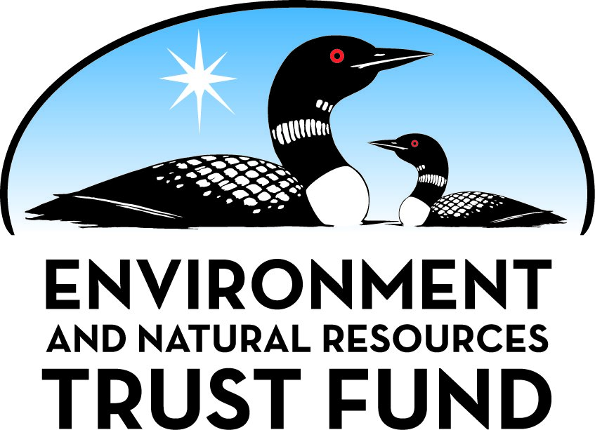

Environment and Natural Resources Trust Fund

M.L. 2025 Final Work Plan

General Information
ID Number: 2025-115
Staff Lead: Noah Fribley
Date this document submitted to LCCMR: June 9, 2025
Project Title: Updating and Sharing Information on Minnesota’s Tick Biodiversity
Project Budget: $186,000

Project Manager Information
Name: Benjamin Cull
Organization: U of MN - College of Food, Agricultural and Natural Resource Sciences
Office Telephone: ( ) -
Email: cull0122@umn.edu
Web Address: https://cfans.umn.edu/

Project Reporting
Reporting Schedule: March 1 / September 1 of each year.
Project Completion: June 30, 2028
Final Report Due Date: August 14, 2028

Legal Information
Legal Citation: M.L. 2025, First Special Session, Chp. 1, Art. 2, Sec. 2, Subd. 03k
Appropriation Language: $186,000 the first year is from the trust fund to the Board of Regents of the University of Minnesota to collaborate with wildlife organizations and community scientists to survey the biodiversity and distribution of ticks in Minnesota and create a publicly accessible GIS dashboard to share results and potential disease implications with the public and wildlife managers.
Appropriation End Date: June 30, 2028

Narrative
Project Summary: This project will update information on the biodiversity and distribution of ticks in Minnesota, and create a publicly accessible GIS dashboard integrating these data with citizen science-sourced tick records.
Describe the opportunity or problem your proposal seeks to address. Include any relevant background information.
Ticks (Order Ixodida) are blood-feeding parasites that infest numerous wildlife species and play important roles in various human and animal diseases. The only comprehensive description of ticks inhabiting Minnesota was published in 1941 and recorded seven species. Since then, thirteen tick species have been reported in Minnesota. However, research has been limited to two or three species of public health importance, and basic information on many ticks associated with wildlife is severely lacking. Most state records of the lesser studied species are over 50 years old and limited to a few specimens in the University’s Insect collection. Therefore, an update of Minnesota’s tick biodiversity is overdue.
Ticks can significantly influence wildlife health through the transmission of pathogens, induction of stress and immunosuppression, blood loss and anemia, and alterations to behavior and population dynamics. However, to evaluate the effects that ticks may have on the state’s wildlife, a fundamental understanding of their distribution and wildlife hosts in Minnesota is required. This baseline data can aid wildlife conservation and serve as a comparator for future changes in wildlife parasite biodiversity impacted by factors such as alterations in wildlife populations, climate, and land use.
What is your proposed solution to the problem or opportunity discussed above? Introduce us to the work you are seeking funding to do. You will be asked to expand on this proposed solution in Activities & Milestones.
This project would establish statewide passive wildlife surveillance for ticks, involving collaboration with wildlife rehabilitation centers, veterinary clinics, DNR wildlife biologists, park districts, hunters, bird ringers, and other groups in contact with wildlife. This surveillance method has proven effective in other states for surveying a diversity of wildlife host species for ticks and, therefore, cataloguing a much more comprehensive range of tick species than methods focusing solely on human encounters with ticks. Sampling equipment (collection vials, tick removal tool, datasheet) and prepaid mailing packs would be supplied to volunteers for return to the UMN for tick identification. Samples will be stored in the UMN Insect Collection, providing a resource and long-term record for other researchers. Submissions from wildlife hosts will be complemented by data from our existing iNaturalist program (Minnesota Tick Activity Monitor) that tracks human-tick encounters across Minnesota.
Data will be uploaded regularly to a publicly accessible ArcGIS StoryMaps-based webpage to maintain volunteer engagement and provide up-to-date information on ticks in Minnesota. ArcGIS StoryMaps allows the integration of photos, text, and maps into an interactive dashboard that facilitates public engagement and data dissemination. The public-facing webpage will be publicized to drive participation, garner support, and receive feedback.
What are the specific project outcomes as they relate to the public purpose of protection, conservation, preservation, and enhancement of the state’s natural resources?
The conservation of Minnesota’s wildlife relies on understanding their interactions with other species, particularly those representing threats to their health, such as parasites. Basic data on tick species associated with Minnesotan wildlife and their distribution are necessary for wildlife managers to assess how anthropogenic change (climate; land use) may affect wildlife-tick interactions and, consequently, wildlife health, as well as evaluate potential transmission of ticks between wildlife and livestock. This project addresses the state’s lack of wildlife tick data by coupling our tick surveillance expertise with stakeholder engagement to produce interactive data dashboards that enhance public awareness of Minnesota’s tick diversity.

Project Location
What is the best scale for describing where your work will take place?
Statewide
What is the best scale to describe the area impacted by your work?
Statewide
When will the work impact occur?
During the Project and In the Future

Activities and Milestones

Activity 1: Update information on the biodiversity and distribution of wildlife ticks in Minnesota through a collaborative citizen science-driven collection scheme
Activity Budget: $96,773
Activity Description:
Ticks will be collected through passive surveillance with the distribution of prepaid tick collection packs to hunters, wildlife centers, recreational areas (state parks, national parks, regional/county park systems), veterinary centers, and other groups that regularly encounter wildlife. Potential groups will be identified throughout the state to achieve a wide distribution across Minnesota and contacted at the start of the project. Prior to the start of the sampling period in January 2026, volunteers will be sent collection packs containing instructions, tools, collection vials, datasheets, and prepaid return mailing envelopes. Volunteers will collect any ticks encountered during their normal activities with wildlife and record information on collection date, host species, geographical location (at least County), and any known out-of-state travel history of the animal host. Samples will be sent to the UMN for identification of tick species and life stages. Specimens will be stored at the UMN Insect Collection as a resource for other researchers and potential use in future studies such as pathogen testing. Sampling period will cover two years: 2026, 2027.
Observations of ticks from across the state will also be collected and identified from the online biodiversity recording platform iNaturalist, through our existing “Minnesota Tick Activity Monitor" project.
Activity Milestones:
Description | Approximate Completion Date
Identify and contact relevant organizations/groups to recruit volunteers | December 31, 2025
Assemble sample collection packs and send to volunteers | December 31, 2025
Ongoing receipt and identification of tick samples and data analysis | December 31, 2027
Ongoing identification and analysis of iNaturalist tick observations | December 31, 2027

Activity 2: Develop an online GIS dashboard to display survey results and provide an educational resource on Minnesota’s tick biodiversity
Activity Budget: $89,227
Activity Description:
An interactive public-facing webpage will be developed using the ArcGIS StoryMaps platform (ESRI) to disseminate information from the project and increase awareness of tick biodiversity in Minnesota. Combining information and images of ticks with regularly updated data collected from Activity 1, this page will enable users to learn about the various tick species in the state, which wildlife hosts they are associated with, and use interactive county-scale maps to explore the known distribution of different tick species in the state. Users will be able to further explore the data using various filters, for example, to see which ticks have been found in their county, which tick species have been found on certain wildlife species, and to compare historical records with results from the current project. For species of potential public or veterinary health concern, pertinent information will be provided, with links to relevant pages of the Minnesota Department of Health, Minnesota DNR, USDA, etc.
Data on the webpage will be regularly updated (monthly) as results are analyzed from the wildlife collections and iNaturalist tick project. This method of data sharing is expected to improve volunteer engagement with the project, aid project publicization, and ultimately improve tick awareness across Minnesota.
Activity Milestones:
Description | Approximate Completion Date
Design and implementation of ArcGIS StoryMaps webpage about Minnesota ticks | December 31, 2025
Monthly updates to tick webpage using data from Activity 1 | December 31, 2027

Project Partners and Collaborators
Name | Organization | Role | Receiving Funds
Renee Schott | Wildlife Rehabilitation Center of Minnesota | Contribute tick samples collected from wildlife | No
UMSP Insect Collection | University of Minnesota | Long-term storage and documentation of collected tick specimens | No

Dissemination
Describe your plans for dissemination, presentation, documentation, or sharing of data, results, samples, physical collections, and other products and how they will follow ENRTF Acknowledgement Requirements and Guidelines.
Results will be documented and shared through the public-facing ArcGIS Storymaps dashboard, described in detail in Activity 2. This will be updated monthly with new results, allowing Minnesotans to observe tick species activity in the state. Relevant entities (e.g. veterinary centers, wildlife groups, park districts, DNR biologists, hunting organizations) will be contacted at the start of the project to invite participation in the collection of wildlife tick samples. Therefore, we expect to be in regular contact with contributing entities and to provide regular updates by email on identification of tick specimens received. As well as results being available on the openly accessible online dashboard, interested state entities may request detailed data from the project that is of particular interest to their work activities. There is potential for local outreach and dissemination activities, e.g. talks or displays at nature centers, that will be arranged based on requests received from entities. The project will also be publicized at the annual UMN Great Minnsect Show and through other University outreach channels (e.g. press release). Results from the project are also expected to be disseminated through the MN master naturalists network run by UMN extension. Tick specimens received during this project will be deposited in the University of Minnesota Insect Collection (St Paul) as a physical record and for use by other researchers, and may be used in outreach activities discussed above. The scientific data arising from this project will also be presented at a national conference and detailed in a scientific journal publication. Major findings relevant to public or wildlife health will be communicated to relevant state agencies (i.e. MDH, DNR) for coordination of required responses. All media, publications, presentations and outreach related to the project will acknowledge the Environment and Natural Resources Trust Fund.

Long-Term Implementation and Funding
Describe how the results will be implemented and how any ongoing effort will be funded. If not already addressed as part of the project, how will findings, results, and products developed be implemented after project completion? If additional work is needed, how will this work be funded?
Results from this project will be used to update current knowledge on wildlife-associated ticks in Minnesota and create a publicly accessible map-based webpage to share the data and improve available information on tick biodiversity. This information can be used to aid wildlife conservation efforts. It is expected that at least one scientific publication will result from this project. Should results highlight the presence and/or significant geographic expansion of tick species of public or veterinary health concern, further publications may be produced, and additional external funding will be sought to carry out further targeted investigations.

Budget Summary
Category / Name | Subcategory or Type | Description | Purpose | Gen. Ineli gible | % Bene fits | # FTE | Class ified Staff? | $ Amount
Personnel
Faculty |  | Overseeing project, mentoring of graduate student, management of iNaturalist project and GIS webpage |  |  | 37.1% | 0.75 |  | $70,371
Graduate student |  | Manage communication with volunteers; sample receipt, identification, and storage; data management and analysis. |  |  | 25.1% | 2 |  | $106,083
 |  |  |  |  |  |  | Sub Total | $176,454
Contracts and Services
 |  |  |  |  |  |  | Sub Total | -
Equipment, Tools, and Supplies
 | Tools and Supplies | Estimated costs of mailing supplies, tick removal tools, tubes for tick collection and storage, forceps, dishes, ethanol | Supplies needed for sending samples to/from volunteers and for the collection, identification and storage of tick samples. |  |  |  |  | $7,546
 |  |  |  |  |  |  | Sub Total | $7,546
Capital Expenditures
 |  |  |  |  |  |  | Sub Total | -
Acquisitions and Stewardship
 |  |  |  |  |  |  | Sub Total | -
Travel In Minnesota
 |  |  |  |  |  |  | Sub Total | -
Travel Outside Minnesota
 | Conference Registration Miles/ Meals/ Lodging | Travel, lodging and registration for one person at an out-of-state conference to present project results | Dissemination of results from the project at a major national conference (likely to be in a different state) | X |  |  |  | $2,000
 |  |  |  |  |  |  | Sub Total | $2,000
Printing and Publication
 |  |  |  |  |  |  | Sub Total | -
Other Expenses
 |  |  |  |  |  |  | Sub Total | -
 |  |  |  |  |  |  | Grand Total | $186,000

Classified Staff or Generally Ineligible Expenses
Category/Name | Subcategory or Type | Description | Justification Ineligible Expense or Classified Staff Request
Travel Outside Minnesota | Conference Registration Miles/Meals/Lodging | Travel, lodging and registration for one person at an out-of-state conference to present project results | Conferences at which findings will be presented, such as those of the Entomological Society of America and The Wildlife Society, are likely to be held outside of Minnesota

Non ENRTF Funds
Category | Specific Source | Use | Status | $ Amount
State
 |  |  | State Sub Total | -
Non-State
 |  |  | Non State Sub Total | -
 |  |  | Funds Total | -

Total Project Cost: $186,000
This amount accurately reflects total project cost?
Yes

Attachments

Required Attachments

Visual Component
File:

Alternate Text for Visual Component
Ticks are collected from wildlife with the help of various groups in contact with animals, and mailed to the University of Minnesota for identification. Tick observation data are also collected from iNaturalist. Both data sources are integrated into an interactive online informational GIS dashboard for data sharing and public education....

Supplemental Attachments

Capital Project Questionnaire, Budget Supplements, Support Letter, Photos, Media, Other
Title | File
Authorization Letter from UMN SPA Cull1129349

Difference between Proposal and Work Plan

Describe changes from Proposal to Work Plan Stage
Added a plan for the dissemination of project data. No other changes have been made to the workplan.
2/5/2025: According to required revisions, the following changes were made: (a) In Budget it is now indicated that conference travel is for one person. (b) Indicated 'No' for the question 'Does your project include original, hypothesis-driven research?' in General Information tab

Additional Acknowledgements and Conditions:
The following are acknowledgements and conditions beyond those already included in the above workplan:
Do you understand and acknowledge the ENRTF repayment requirements if the use of capital equipment changes?
N/A
Do you understand that travel expenses are only approved if they follow the "Commissioner's Plan" promulgated by the Commissioner of Management of Budget or, for University of Minnesota projects, the University of Minnesota plan?
Yes, I understand the UMN Policy on travel applies.
Does your project have potential for royalties, copyrights, patents, sale of products and assets, or revenue generation?
No
Do you understand and acknowledge IP and revenue-return and sharing requirements in 116P.10?
N/A
Do you wish to request reinvestment of any revenues into your project instead of returning revenue to the ENRTF?
N/A
Does your project include original, hypothesis-driven research?
No
Does the organization have a fiscal agent for this project?
Yes, Sponsored Projects Administration
Does your project include the pre-design, design, construction, or renovation of a building, trail, campground, or other fixed capital asset costing $10,000 or more or large-scale stream or wetland restoration?
No
Do you propose using an appropriation from the Environment and Natural Resources Trust Fund to conduct a project that provides children's services (as defined in Minnesota Statutes section 299C.61 Subd.7 as "the provision of care, treatment, education, training, instruction, or recreation to children")?
No
Provide the name(s) and organization(s) of additional individuals assisting in the completion of this project:
Andrea Little (University of Minnesota)
Do you understand that a named service contract does not constitute a funder-designated subrecipient or approval of a sole-source contract? In other words, a service contract entity is only approved if it has been selected according to the contracting rules identified in state law and policy for organizations that receive ENRTF funds through direct appropriations, or in the DNR’s reimbursement manual for non-state organizations. These rules may include competitive bidding and prevailing wage requirements
N/A

