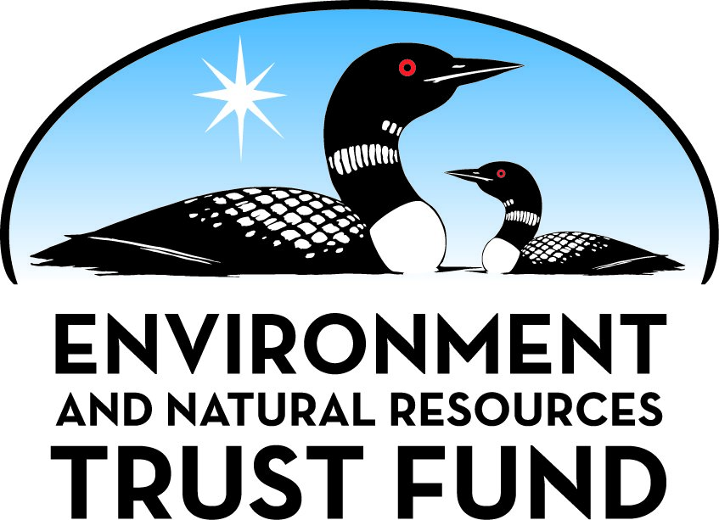

Environment and Natural Resources Trust Fund

M.L. 2025 Final Work Plan

General Information
ID Number: 2025-081
Staff Lead: Michael Varien
Date this document submitted to LCCMR: June 9, 2025
Project Title: Mesabi Trail Aurora to Hoyt Lakes
Project Budget: $1,325,000

Project Manager Information
Name: Sarah Ciochetto
Organization: St. Louis & Lake Counties Regional Railroad Authority
Office Telephone: (218) 744-6150
Email: sarah@rrauth.com
Web Address:

Project Reporting
Reporting Schedule: March 1 / September 1 of each year.
Project Completion: June 30, 2028
Final Report Due Date: August 14, 2028

Legal Information
Legal Citation: M.L. 2025, First Special Session, Chp. 1, Art. 2, Sec. 2, Subd. 09b
Appropriation Language: $1,325,000 the first year is from the trust fund to the commissioner of natural resources for an agreement with St. Louis and Lake Counties Regional Railroad Authority for environmental review and permitting and to engineer, design, and construct a segment of the Mesabi Trail beginning at the intersection of Main Street and Forestry Road in Aurora toward Hoyt Lakes.
Appropriation End Date: June 30, 2028

Narrative
Project Summary: The construction of an approximately 4.5 mile-long segment of the Mesabi Trail beginning at the intersection of Main Street (CR 100) and Forestry Road in Aurora toward Hoyt Lakes.
Describe the opportunity or problem your proposal seeks to address. Include any relevant background information.
Running from the Mississippi to the Boundary Waters, the Mesabi Trail, owned and maintained by the St Louis and Lake Counties Regional Railroad Authority (RRA), is a planned 10 ft wide, 165 mile-long paved trail that serves as an alternate transportation corridor and recreational facility for non-motorized use namely pedestrian, bike, ski, snowshoe and in designated areas, winter snowmobile use. Since inception year 1995, approximately 150 miles of the trail have been constructed in cooperation with local landowners and governments, and State and Federal lands with no eminent domain proceedings. The trail will connect twenty-nine (29) communities across two counties starting in Grand Rapids and ending in Ely. Seeing over 250,000 users each year, a number which is steadily growing, the trail is becoming a sought after tourist destination which can help drive economic development in NE Minnesota. This proposed project will connect the community of Hoyt Lakes to the trail corridor and will positively affect trail users through access to lodging, restaurants, and other amenities. This will also benefit Hoyt Lakes as more tourism dollars will come to their community and local residents will also gain a safe environment to encourage more activity for healthier lives.
What is your proposed solution to the problem or opportunity discussed above? Introduce us to the work you are seeking funding to do. You will be asked to expand on this proposed solution in Activities & Milestones.
Completion of an entire planned 165-mile-long trail, requires smaller, more manageable trail segments to be constructed over time. The Main Street (CR 100) to Hoyt Lakes Segment (hereafter known as the “Project”) is an approximately 4.5-mile long segment of 10-foot wide bituminous paved surface with 2-foot gravel shoulders designed to MnDOT Bicycle Facility Manual standards and ADA compliant. The Project will begin at the intersection of Main Street (CR 100) and Forestry Road in Aurora and then traverse East and South approximately 4.5 miles to the city of Hoyt Lakes where an access point and kiosk will be added near the ball fields. The preferred route for this Mesabi Trail segment is located away from the highway right of way crossing privately owned land through a similar corridor where atv and snowmobile trails are currently located. There will be enough separation of the trails that no conflict of users should occur. The trail route will emerge into the Hwy 110 right of way to cross the Partridge River on the bridge shoulder and will remain within the county right of way the rest of the distance into town.
What are the specific project outcomes as they relate to the public purpose of protection, conservation, preservation, and enhancement of the state’s natural resources?
Offering a defined corridor, the Mesabi Trail protects and enhances the state's many and varied natural resources as it traverses the arrowhead region. Following the trail allows users to experience nature without damaging fragile vegetation. The route touches varied landscapes, state parks, state, county, and federal forests, lakes, streams and many cultural settings. Many trail segments follow historic transportation corridors where interpretive signage shares cultural aspects from Indigenous peoples to loggers and iron miners. Current mining operations can be viewed as well. The trail connects communities, provides a defined transportation corridor, and promotes healthy lifestyles.

Project Location
What is the best scale for describing where your work will take place?
Region(s): NE
What is the best scale to describe the area impacted by your work?
Region(s): NE
When will the work impact occur?
During the Project

Activities and Milestones

Activity 1: Environmental and Permitting (Act. 1)
Activity Budget: $170,000
Activity Description:
Environmental work needed to comply with the Federal National Environmental Policy Act (NEPA) and State of Minnesota Environmental Protection Act (MEPA).
Primary oversight and permitting agencies include the Federal Army Corps of Engineers, Minnesota Pollution Control Agency, Minnesota Board of Water and Soil Resources, the Local Board of Soil and Water Conservation, MN Department of Natural Resources, and the MN State Historic Preservation Office.
The environmental work will be supported by engineering work to locate alternative trail routes, survey cultural resource locations, survey wetland boundaries, establish property lines and identify land ownership.
Geotechnical work may occur if unsuitable soils or ledge rock is encountered.
Work will be performed by a person or firm accredited by the Minnesota Board of Water and Soil Resources (BWSR) hereafter known as “Consultant”. Consultant will perform work needed to comply with NEPA and MEPA documenting trail route alternatives, cultural resource identification, wetland delineation & mitigation, endangered species, social impacts, economic impacts, state waters impacts, land use (4f) and other. Consultant will further evaluate and assure compliance with local ordinances, planning, zoning and codes.
Activity Milestones:
Description | Approximate Completion Date
1. Prepare wetland delineation, applications, and requests for review, consultation w SHPO, Agency reviews | February 28, 2025
2. Work with agencies on any revisions or modifications required | June 30, 2025
3. Approvals and permits from required agencies | April 30, 2026

Activity 2: Engineering survey, design, planning and construction management (Act. 2)
Activity Budget: $130,000
Activity Description:
Engineering will be done in accordance with the MN DOT Standards for Bicycle Trails. Engineering work begins with route(s) identification and support of environmental work and then to more specific survey work once a preferred trail route alternative is selected. The project engineer will design the trail in accordance with MN DOT and ASHTO standards while taking into account on-site conditions such as waterways, wetlands, hills, valleys and other features to determine the final trail location and design.
Engineer, working in cooperation with the environmental consultant, will perform design, provide construction plan and specifications. Engineer will also perform construction management, on-site inspections, testing oversight and other functions.
Activity Milestones:
Description | Approximate Completion Date
1. Support for environmental work, survey/delineation | November 30, 2024
2. Approval of draft Plans and specifications | June 30, 2025
3. Approval of final plans and specs, advertise for bids | February 28, 2026

Activity 3: Trail construction (Act. 3)
Activity Budget: $1,025,000
Activity Description:
Construct a 10' wide bituminous surfaced trail approximately 4.5 miles in length built in accordance with the engineering plan. Trail construction will include 2' wide gravel shoulders, base preparation, grading, gravel base, ditch ways, slopes, culverts, fencing, signing, landscaping, seeding, and all else necessary for a complete trail. We have included with other funds a MN State Bond grant of $1,138,000 applied towards trail construction.
Construction will be performed by a licensed and bonded contractor. Project bidding, contractor selection and contracts will be performed in accordance with the St. Louis County Public Project Procurement Process administered by the St. Louis County Purchasing Department.
Activity Milestones:
Description | Approximate Completion Date
Award contract, obtain permits, precon meetings, staking, mobilization, and site prep | May 31, 2026
Construction, oversight and administration | May 31, 2026
Change Orders, final grading, and substantial completion | August 31, 2026
Close out: stabilization, punch list items, asbuilts, NOFR, cert of Occupancy equivalent | October 31, 2026
Signage installed, open for intended use | October 31, 2026

Dissemination
Describe your plans for dissemination, presentation, documentation, or sharing of data, results, samples, physical collections, and other products and how they will follow ENRTF Acknowledgement Requirements and Guidelines.
The ENRTF logo and language is on our printed trail maps, on the main page of the Mesabi Trail website, and tagged on our Facebook marketing videos. We have ENRTF logos at some of the kiosks and as we update our wayfinding and MT logo signage, we will add the ENRTF logo to all trail kiosks in prominent positions.

Long-Term Implementation and Funding
Describe how the results will be implemented and how any ongoing effort will be funded. If not already addressed as part of the project, how will findings, results, and products developed be implemented after project completion? If additional work is needed, how will this work be funded?
Long term strategy for the Mesabi Trail has not changed since 1995 which is to construct a trail from Grand Rapids to Ely connecting 29 communities along the way. Seeking eligible grants to complete the trail is an on-going process. A key component is to maintain the trail to last for a period of 20 years. The Regional Railroad Authority has committed to maintain the trail and currently employs 1 full-time and 4 part-time employees to maintain the trail with an annual budget of $390,000.

Other ENRTF Appropriations Awarded in the Last Six Years
Name | Appropriation | Amount Awarded
Mesabi Trail Development - Soudan to Ely Segment | M.L. 2014, Chp. 226, Sec. 2, Subd. 07c | $1,000,000
Mesabi Trail Development Soudan to Ely - Phase II | M.L. 2015, Chp. 76, Sec. 2, Subd. 09i | $1,000,000
Mesabi Trail Segment from Highway 135 to Town of Embarrass | M.L. 2016, Chp. 186, Sec. 2, Subd. 09e | $1,200,000
Mesabi Trail Development | M.L. 2017, Chp. 96, Sec. 2, Subd. 09g | $2,269,000
Develop Mesabi Trail Segment From County Road 88 to Ely | M.L. 2018, Chp. 214, Art. 4, Sec. 2, Subd. 09b | $600,000
Mesabi Trail Extensions | M.L. 2019, First Special Session, Chp. 4, Art. 2, Sec. 2, Subd. 09g | $3,000,000
Historic Bruce Mine Park and Mesabi Trailhead | M.L. 2019, First Special Session, Chp. 4, Art. 2, Sec. 2, Subd. 09q | $1,000,000

Budget Summary
Category / Name | Subcategory or Type | Description | Purpose | Gen. Ineli gible | % Bene fits | # FTE | Class ified Staff? | $ Amount
Personnel
 |  |  |  |  |  |  | Sub Total | -
Contracts and Services
Widseth | Service Contract | Contract with firm Widseth for environmental work and permitting |  |  |  | 6.3 |  | $170,000
Widseth | Service Contract | Engineering and construction management for trail |  |  |  | 3 |  | $161,000
TBD | Service Contract | Construct bituminous surfaced trail |  |  |  | 6 |  | $994,000
 |  |  |  |  |  |  | Sub Total | $1,325,000
Equipment, Tools, and Supplies
 |  |  |  |  |  |  | Sub Total | -
Capital Expenditures
 |  |  |  |  |  |  | Sub Total | -
Acquisitions and Stewardship
 |  |  |  |  |  |  | Sub Total | -
Travel In Minnesota
 |  |  |  |  |  |  | Sub Total | -
Travel Outside Minnesota
 |  |  |  |  |  |  | Sub Total | -
Printing and Publication
 |  |  |  |  |  |  | Sub Total | -
Other Expenses
 |  |  |  |  |  |  | Sub Total | -
 |  |  |  |  |  |  | Grand Total | $1,325,000

Classified Staff or Generally Ineligible Expenses
Category/Name | Subcategory or Type | Description | Justification Ineligible Expense or Classified Staff Request

Non ENRTF Funds
Category | Specific Source | Use | Status | $ Amount
State
Cash | Representative Lislegard tax allowance | Development and construction | Secured | $500,000
 |  |  | State Sub Total | $500,000
Non-State
Cash | Northeast Minnesota Area Transportation Partnership (NEMNATP) Transportation Alternatives (TA) Program (Federal) | Used for trail construction | Secured | $450,000
Cash | Carbon Reduction Program grant (Federal) | Used for trail construction | Secured | $1,170,000
 |  |  | Non State Sub Total | $1,620,000
 |  |  | Funds Total | $2,120,000

Total Project Cost: $3,445,000
This amount accurately reflects total project cost?
Yes

Attachments

Required Attachments

Visual Component
File:

Alternate Text for Visual Component
Mesabi Trail: segment map from Main Street (CR 100) in Aurora to community center in Hoyt Lakes...

Financial Capacity
Title | File
2022 Audit Report

Board Resolution or Letter
Title | File
RRA Board Resolution

Supplemental Attachments

Capital Project Questionnaire, Budget Supplements, Support Letter, Photos, Media, Other
Title | File
Hoyt Lakes Letter of Support
Engineer's Cost Estimate
Budget Addendum_Received post-close
Construction Questionnaire_Received post-close
Budget addendum 8 16 24
Town of White Letter of Support
Aurora Letter of Support

Difference between Proposal and Work Plan

Describe changes from Proposal to Work Plan Stage
Budget addendum has been updated to reflect amount received from ENRTF and secured match funding, letters of support have been added, Activities and milestones have been updated. 5 9 25 work plan review comments corrected 6 4 25 review comment corrected

Additional Acknowledgements and Conditions:
The following are acknowledgements and conditions beyond those already included in the above workplan:
Do you understand and acknowledge the ENRTF repayment requirements if the use of capital equipment changes?
N/A
Do you understand that travel expenses are only approved if they follow the "Commissioner's Plan" promulgated by the Commissioner of Management of Budget or, for University of Minnesota projects, the University of Minnesota plan?
N/A
Does your project have potential for royalties, copyrights, patents, sale of products and assets, or revenue generation?
No
Do you understand and acknowledge IP and revenue-return and sharing requirements in 116P.10?
N/A
Do you wish to request reinvestment of any revenues into your project instead of returning revenue to the ENRTF?
N/A
Does your project include original, hypothesis-driven research?
No
Does the organization have a fiscal agent for this project?
No
Does your project include the pre-design, design, construction, or renovation of a building, trail, campground, or other fixed capital asset costing $10,000 or more or large-scale stream or wetland restoration?
Yes
Do you propose using an appropriation from the Environment and Natural Resources Trust Fund to conduct a project that provides children's services (as defined in Minnesota Statutes section 299C.61 Subd.7 as "the provision of care, treatment, education, training, instruction, or recreation to children")?
No
Provide the name(s) and organization(s) of additional individuals assisting in the completion of this project:
Bill Dahl and Bob Manzoline, St Louis & Lake Counties Regional Railroad Authority
Do you understand that a named service contract does not constitute a funder-designated subrecipient or approval of a sole-source contract? In other words, a service contract entity is only approved if it has been selected according to the contracting rules identified in state law and policy for organizations that receive ENRTF funds through direct appropriations, or in the DNR’s reimbursement manual for non-state organizations. These rules may include competitive bidding and prevailing wage requirements
Yes, I understand

