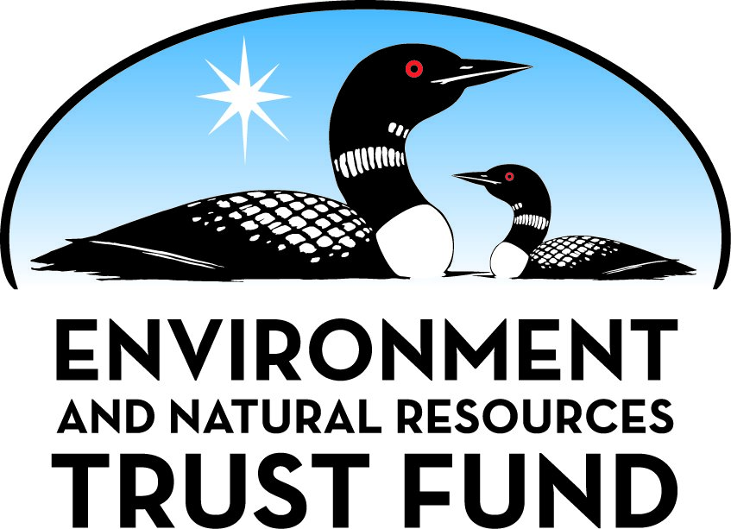

Environment and Natural Resources Trust Fund

M.L. 2025 Final Work Plan

General Information
ID Number: 2025-073
Staff Lead: Tom Dietrich
Date this document submitted to LCCMR: June 17, 2025
Project Title: Statewide Environmental Education via PBS Outdoor Series
Project Budget: $415,000

Project Manager Information
Name: Sherece Lamke
Organization: Pioneer PBS
Office Telephone: (320) 289-2915
Email: slamke@pioneer.org
Web Address: https://www.pioneer.org/

Project Reporting
Reporting Schedule: March 1 / September 1 of each year.
Project Completion: June 30, 2028
Final Report Due Date: August 14, 2028

Legal Information
Legal Citation: M.L. 2025, First Special Session, Chp. 1, Art. 2, Sec. 2, Subd. 05g
Appropriation Language: $415,000 the first year is from the trust fund to the commissioner of natural resources for an agreement with Pioneer Public Broadcasting Service to produce, distribute, and promote new episodes of a statewide public television series that inspires Minnesotans to connect with the outdoors and to restore and protect the state's natural resources.
Appropriation End Date: June 30, 2028

Narrative
Project Summary: Pioneer PBS will produce 26 new episodes of a statewide television series designed to inspire Minnesotans to connect with the outdoors and to restore and protect our valuable natural resources.
Describe the opportunity or problem your proposal seeks to address. Include any relevant background information.
This project addresses the long-term need for environmental education, engagement and tools that Minnesotans can use to restore and protect our valuable natural resources. High-quality video programming is an enjoyable way to educate Minnesotans about research and advancements in natural resource management and agricultural practices such as tracking and capturing invasive carp and powering robotic weed terminators with solar energy. Stories show how we can all improve water quality, protect wildlife habitat, promote pollinators, restore our natural world and avoid practices that can be detrimental to the environment. For example, a recent survey revealed that about 20% of Minnesota anglers who use live bait have released unused baitfish into waters, which can introduce pathogens and invasive species. Most of those anglers do not know the practice is illegal and harmful to the environment. Also, to counteract the trend of spending more time on screens and less time outdoors, stories present ways to connect kids to nature and show the health benefits of spending time outdoors. The program's opportunity is to reach out to a statewide audience and inspire viewers to connect with the natural world, increase their environmental science knowledge and adopt conservation practices.
What is your proposed solution to the problem or opportunity discussed above? Introduce us to the work you are seeking funding to do. You will be asked to expand on this proposed solution in Activities & Milestones.
Engaging, high-quality stories that show the environmental harm of certain practices, along with opportunities to protect and restore nature, can inspire people to make changes in their purchases and behaviors. The award-winning Pioneer PBS production Prairie Sportsman features at least one story each episode on research and natural resource management and agricultural practices that benefit the environment. Each episode also includes a sports and recreation stories that presents fun ways to connect with the outdoors, which is the path to environmental stewardship. Pioneer PBS proposes to produce two new seasons of Prairie Sportsman to be broadcast in 2026 and 2027 from late January to mid-May. Two 13-episode seasons will be filmed at locations throughout the state and feature a wide range of topics that appeal to a diverse audience. The project will also include easy online access to stories featuring ENRTF-supported projects. All Minnesota PBS stations are airing Prairie Sportsman. In addition, the state’s conservation accomplishments are showcased on PBS stations airing Prairie Sportsman in Wisconsin, South Dakota, Iowa, Wyoming and western Illinois. Prairie Sportsman conservation and wildlife research stories have received three Upper Midwest Emmy awards and Bret Amundson has received an Emmy for his hosting talent.
What are the specific project outcomes as they relate to the public purpose of protection, conservation, preservation, and enhancement of the state’s natural resources?
This project provides a statewide television and online audience with inspirational and educational environmental science and conservation content. Individual segments contained within this project’s 26 episodes will be produced as stand-alone videos, distributed online and made available to public and private organizations involved in the segments’ production. The Prairie Sportsman website will also provide a branded link to stories on ENRTF-funded projects. This extends each segment's "evergreen" public education and outreach value for years to come. Past segments have been included in educational programs of the Minnesota DNR, research centers, wildlife associations, schools and colleges, lake associations and others.

Project Location
What is the best scale for describing where your work will take place?
Statewide
What is the best scale to describe the area impacted by your work?
Statewide
When will the work impact occur?
During the Project and In the Future

Activities and Milestones

Activity 1: Produce, promote and distribute 26 episodes, with at least 26 environmental education segments, to air on all Minnesota PBS stations.
Activity Budget: $394,250
Activity Description:
The two 13-episode seasons will include a minimum of 26 environmental education segments on research, natural resource management and agricultural practices that benefit the environment. Episodes will also include outdoor sports and recreation stories that inspire Minnesotans to connect with the outdoors, and special features on citizen scientists, artists, chefs and others connecting with nature in innovative ways. Broadcast in 2026 and 2027 from late January to mid-May, the two seasons will be filmed at locations throughout the state and feature a wide range of topics that appeal to diverse, changing demographics as well as traditional viewers. The programs will air on Minnesota PBS stations including Pioneer PBS (transmitted from Appleton/Fergus Falls/Worthington), KSMQ (Austin), Lakeland PBS (Bemidji/Brainerd), tptLife (Twin Cities), WDSE (Duluth) and the MN Channel, carried by all Minnesota PBS stations and Prairie Public TV in Fargo.
Activity Milestones:
Description | Approximate Completion Date
Produce 13 episodes with 13 environmental education segments for the 2026 season | May 31, 2026
Create descriptions and images for 2026 stories linked to online viewing platforms | May 31, 2026
Produce 13 episodes with 13 environmental education segments for the 2027 season | May 31, 2027
Create descriptions and images for 2027 stories linked to online viewing platforms | May 31, 2027

Activity 2: Segment, distribute and promote individual stories from each episode, and include a branded link to ENRTF stories.
Activity Budget: $20,750
Activity Description:
Segment individual stories from each episode. Provide a branded link to stories featuring Environment and Natural Resources Trust Fund projects on the Prairie Sportsman website. Promote all episodes and individual stories through social media, e-newsletters and other communications.
Activity Milestones:
Description | Approximate Completion Date
Provide a link to 2026 stories about ENRTF projects on Prairie Sportsman website | June 30, 2026
Promote 2026 episodes and individual segments through outreach and social media | December 31, 2026
Provide a link to 2027 stories about ENRTF projects on Prairie Sportsman website | June 30, 2027
Promote 2027 episodes and individual segments through outreach and social media | June 30, 2027

Dissemination
Describe your plans for dissemination, presentation, documentation, or sharing of data, results, samples, physical collections, and other products and how they will follow ENRTF Acknowledgement Requirements and Guidelines.
This project provides a statewide television and online audience with inspirational and educational environmental science and conservation content. Individual segments contained within this project’s 26 episodes will be produced as stand-alone videos, distributed online and made available on thumb drive or other accessible format to public agencies, learning centers, outdoor organizations, civic organizations and educational institutions, along with branded online access to stories about ENRTF-funded projects. This extends each segment's "evergreen" public education and outreach value for years to come. Major funding from the Environment and Natural Resources Trust will be acknowledged through voice over and the ENRTF logo at the beginning and end of every Prairie Sportsman episode broadcast on all Minnesota PBS stations and online. The logo preceded by the text "Major funding provided by" will appear at the end of every individual segment distributed through the online PBS video platform, social media and thumb drives. The ENRTF logo is also included on all Prairie Sportsman communications, including our website, e-newsletter and other communications.

Long-Term Implementation and Funding
Describe how the results will be implemented and how any ongoing effort will be funded. If not already addressed as part of the project, how will findings, results, and products developed be implemented after project completion? If additional work is needed, how will this work be funded?
Prairie Sportsman stories are "evergreen" videos and can be broadcast and used in educational settings for years to come. The program's statewide focus and high-quality content has steadily increased our audience reach. Production and other related expenses above the ENRTF grant are covered by sponsorships and Pioneer PBS membership dollars. The matching funds cover travel, transcripts, closed-captioning, voice work, marketing, other production expenses and portions of salaries for Pioneer PBS staff personnel who contribute to Prairie Sportsman’s marketing, communications, financial management and administration.

Other ENRTF Appropriations Awarded in the Last Six Years
Name | Appropriation | Amount Awarded
New Prairie Sportsman Statewide Broadcast Video Project | M.L. 2016, Chp. 186, Sec. 2, Subd. 05d | $300,000
Prairie Sportsman Statewide Environmental Broadcasts and Videos | M.L. 2018, Chp. 214, Art. 4, Sec. 2, Subd. 05a | $300,000
Statewide Environmental Education via PBS Outdoor Series | M.L. 2023, , Chp. 60, Art. 2, Sec. 2, Subd. 05b | $391,000

Budget Summary
Category / Name | Subcategory or Type | Description | Purpose | Gen. Ineli gible | % Bene fits | # FTE | Class ified Staff? | $ Amount
Personnel
Executive Producer/Writer/Videographer/Editor |  | Serve as primary program producer and editor, and manage all aspects of production, including story lineup, videography, interviews, scripting, editing, graphics, post-production and communications. |  |  | 22% | 2 |  | $118,378
Videographer/editor |  | Provide story development, videography, editing and other production and communication services. |  |  | 22% | 2 |  | $96,622
 |  |  |  |  |  |  | Sub Total | $215,000
Contracts and Services
Host/Producer/Videographer/Editor Bret Amundson | Service Contract | Bret Amundson will continue to serve as on-air program host, providing on-camera interviews and narration. In addition, he writes and produces sports, recreation and related conservation stories, advises on all segments and episodes, and promotes stories on social media. |  |  |  | 1.5 |  | $120,000
Videographer/Editor/Production Assistant Dan Amundson | Service Contract | Dan Amundson will continue to assist the Host with videography and editing for outdoor sports, recreation and conservation stories. |  |  |  | 1.5 |  | $80,000
 |  |  |  |  |  |  | Sub Total | $200,000
Equipment, Tools, and Supplies
 |  |  |  |  |  |  | Sub Total | -
Capital Expenditures
 |  |  |  |  |  |  | Sub Total | -
Acquisitions and Stewardship
 |  |  |  |  |  |  | Sub Total | -
Travel In Minnesota
 |  |  |  |  |  |  | Sub Total | -
Travel Outside Minnesota
 |  |  |  |  |  |  | Sub Total | -
Printing and Publication
 |  |  |  |  |  |  | Sub Total | -
Other Expenses
 |  |  |  |  |  |  | Sub Total | -
 |  |  |  |  |  |  | Grand Total | $415,000

Classified Staff or Generally Ineligible Expenses
Category/Name | Subcategory or Type | Description | Justification Ineligible Expense or Classified Staff Request

Non ENRTF Funds
Category | Specific Source | Use | Status | $ Amount
State
 |  |  | State Sub Total | -
Non-State
Cash | Underwriting sponsorships and Pioneer members | Covers production expenses including travel, transcripts, closed captioning, equipment, supplies, voice work, Pioneer financial management, communications, marketing and other costs. | Pending | $160,569
 |  |  | Non State Sub Total | $160,569
 |  |  | Funds Total | $160,569

Total Project Cost: $575,569
This amount accurately reflects total project cost?
Yes

Attachments

Required Attachments

Visual Component
File:

Alternate Text for Visual Component
Map of Minnesota PBS stations viewing areas...

Financial Capacity
Title | File
24 990

Board Resolution or Letter
Title | File
Pioneer PBS Board Resolution

Difference between Proposal and Work Plan

Describe changes from Proposal to Work Plan Stage
The program manager was changed to Sherece Lamke, updated to current 990

Additional Acknowledgements and Conditions:
The following are acknowledgements and conditions beyond those already included in the above workplan:
Do you understand and acknowledge the ENRTF repayment requirements if the use of capital equipment changes?
N/A
Do you understand that travel expenses are only approved if they follow the "Commissioner's Plan" promulgated by the Commissioner of Management of Budget or, for University of Minnesota projects, the University of Minnesota plan?
N/A
Does your project have potential for royalties, copyrights, patents, sale of products and assets, or revenue generation?
No
Do you understand and acknowledge IP and revenue-return and sharing requirements in 116P.10?
N/A
Do you wish to request reinvestment of any revenues into your project instead of returning revenue to the ENRTF?
N/A
Does your project include original, hypothesis-driven research?
No
Does the organization have a fiscal agent for this project?
No
Does your project include the pre-design, design, construction, or renovation of a building, trail, campground, or other fixed capital asset costing $10,000 or more or large-scale stream or wetland restoration?
No
Do you propose using an appropriation from the Environment and Natural Resources Trust Fund to conduct a project that provides children's services (as defined in Minnesota Statutes section 299C.61 Subd.7 as "the provision of care, treatment, education, training, instruction, or recreation to children")?
No
Provide the name(s) and organization(s) of additional individuals assisting in the completion of this project:
Sherece Lamke, Pioneer PBS
Do you understand that a named service contract does not constitute a funder-designated subrecipient or approval of a sole-source contract? In other words, a service contract entity is only approved if it has been selected according to the contracting rules identified in state law and policy for organizations that receive ENRTF funds through direct appropriations, or in the DNR’s reimbursement manual for non-state organizations. These rules may include competitive bidding and prevailing wage requirements
Yes, I understand

